Assignment 1
Penetration Test Report:
- OWASP Vulnerability Category & Name
- Category: A01:2021 - Broken Access Control.
- Vulnerability Name: unauthorized user access & privilege escalation
- Description
The application suffers from Broken Access Control, allowing unauthorized users to access restricted resources and manipulate session variables to escalate privileges. The following issues were identified:
Issues Identified:
- User Impersonation via URL Manipulation:- Users can access dashboard.php directly without logging in.
- Unauthorized Access to Accounts and Transactions:- Non-authenticated users can access certain pages by directly navigating to them.
- Privilege Escalation via Session Manipulation:- A lower-privileged user (e.g., a normal user) can change their user_id to an admin's ID and gain elevated access.
- Role Selection is User-Controlled: Users can register as admins, leading to unauthorized administrative access.
- Image of Beginning Request
(Screenshot of a user accessing another user's profile using a modified user_id in the URL)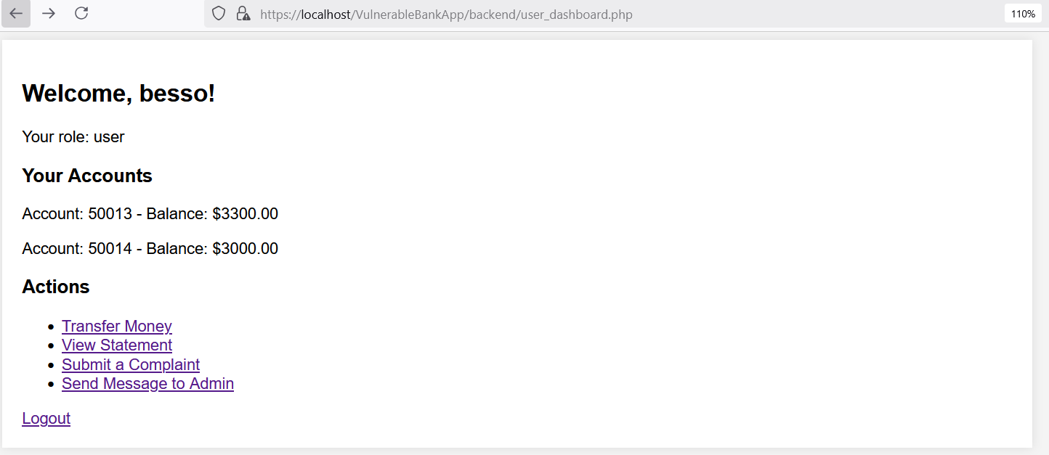

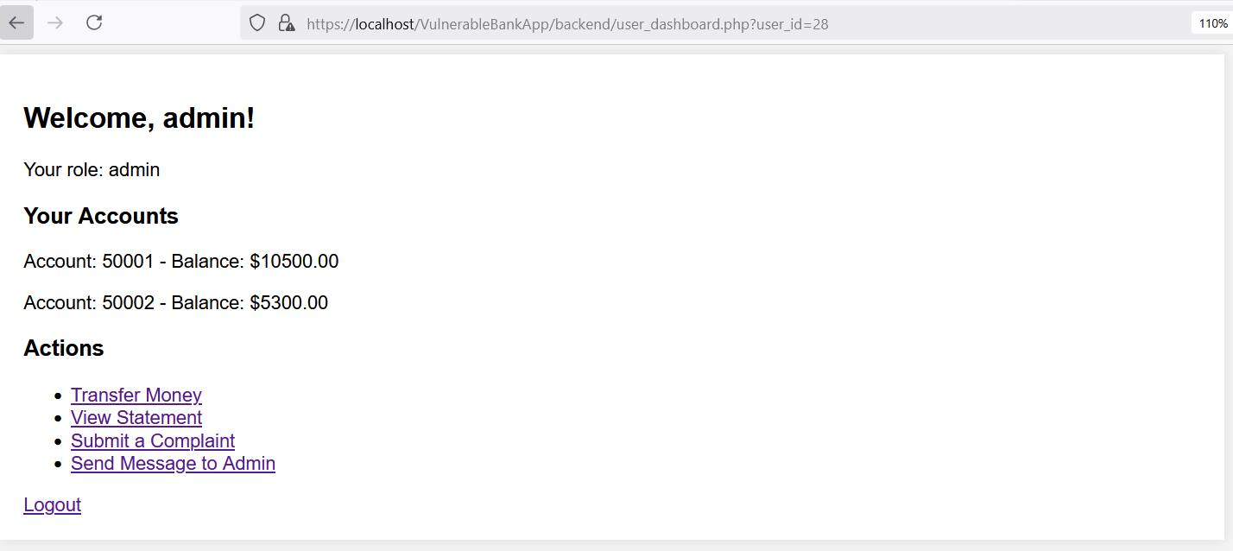

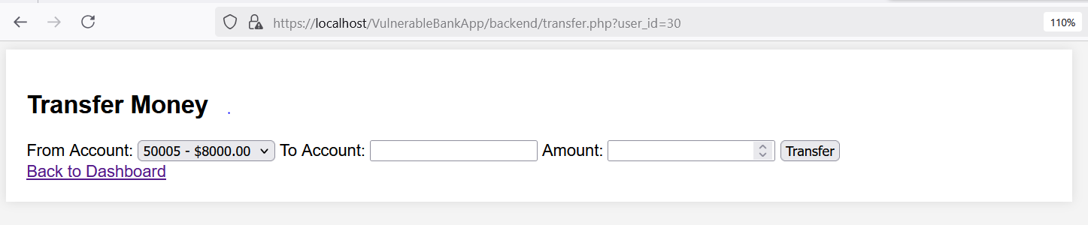

- Steps of Malicious Request / Attack and Impact
Step 1: Unauthorized Access to User Accounts
Malicious Request:
- A normal user logs in and then manually modifies the URL to access another user's account:
- If no proper authorization check is in place, the attacker will see another user’s profile.
Impact:
- Sensitive personal information (such as balance, transactions) is exposed to unauthorized users.
Step 2: Privilege Escalation by Changing user_id in Requests
Malicious Request:
- A regular user attempts to access an admin page by changing the session user ID in a request: $_SESSION['user_id'] = 1; // Manually set to an admin's ID
- If the system does not verify roles correctly, the attacker gains admin privileges.
Impact:
- The attacker gains access to any account, including admin accounts. The attacker can delete user accounts, approve unauthorized transactions, or steal sensitive data.
Step 3: User-Controlled Role Selection in Registration
Malicious Request:
- A user can register as an admin by modifying the request payload.
- This allows unauthorized privilege escalation from the beginning.
Impact:
- Attackers can create an admin account for themselves.
- They can gain full control over the system, bypassing all authentication checks.

- Code Before and After Fixes
Vulnerable Code (Before Fix)
Transfer.php
// Broken Access Control: Allow user_id manipulation via GET request
$user_id = isset($_GET['user_id']) ? $_GET['user_id'] : $_SESSION['user_id'];

// Broken Access Control: No check if 'from_account' belongs to the user_id
$from_account_check = $conn->query("SELECT * FROM accounts WHERE account_number = '$from_account'");

// Enforce session-based authentication (Fix Broken Access Control)
$user_id = $_SESSION['user_id'];

// Validate that 'from_account' belongs to the logged-in user
$from_account_check = $conn->prepare("SELECT * FROM accounts WHERE account_number = ? AND user_id = ?");
$from_account_check->bind_param("si", $from_account, $user_id);
$from_account_check->execute();
$from_account_result = $from_account_check->get_result();
User_dashboard.php
// Broken Access Control: Allow user_id manipulation via GET request
$user_id = isset($_GET['user_id']) ? $_GET['user_id'] : $_SESSION['user_id'];

// Enforce session-based authentication (Fix Broken Access Control)
$user_id = $_SESSION['user_id'];
Register.php
$role = $_POST['role']; // Allow users to select role (vulnerable)

Secure Code (After Fix)
Transfer.php
// Enforce session-based authentication (Fix Broken Access Control)
$user_id = $_SESSION['user_id'];

// Validate that 'from_account' belongs to the logged-in user
$from_account_check = $conn->prepare("SELECT * FROM accounts WHERE account_number = ? AND user_id = ?");
User_dashboard.php
// Enforce session-based authentication (Fix Broken Access Control)
$user_id = $_SESSION['user_id'];
Register.php
// Fix: Prevent users from selecting their own role
$role = 'user'; // Default role assignment
(A screenshot showing an unauthorized user trying to access another user’s dashboard but being redirected to their own dashboard instead.)
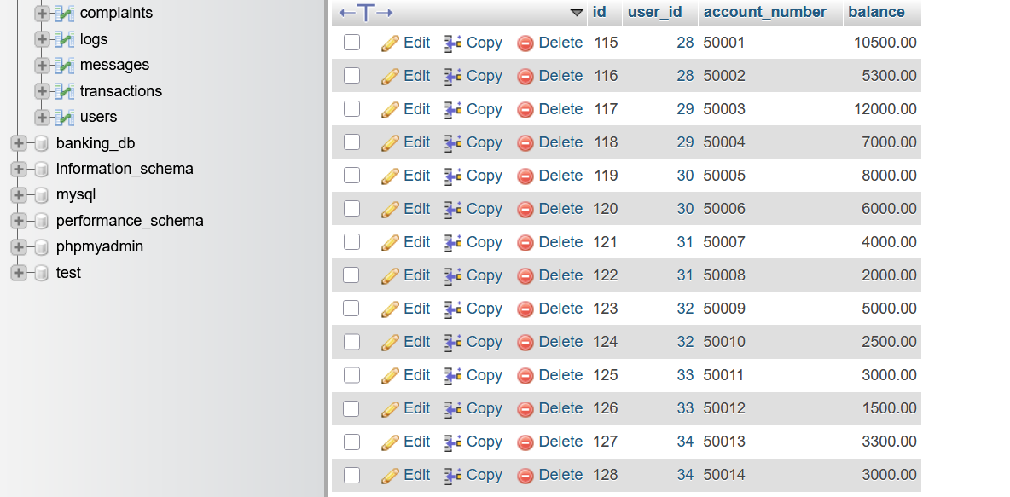
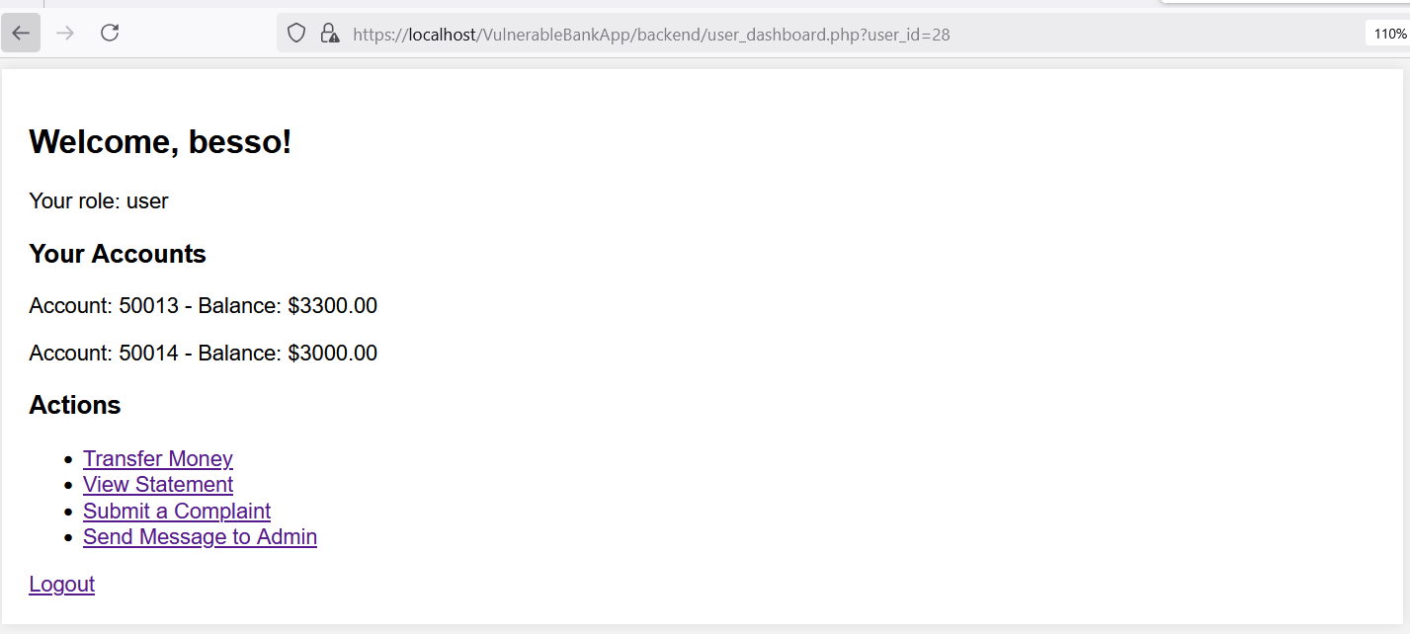
- Description of Fixes
Fix 1: Enforce Session-Based Authentication
- Removed the ability to modify user_id via URL (GET parameters).
- Forced authentication using session variables:
$user_id = $_SESSION['user_id'];
Fix 2: Validate User Ownership of Accounts
- Added validation to ensure users can only transfer money from their own accounts:
$from_account_check = $conn->prepare("SELECT * FROM accounts WHERE account_number = ? AND user_id = ?");
Fix 3: Prevent Privilege Escalation
- Before the fix, any user could change their session ID and act as an admin.
- Now, access checks rely on secure session-based authentication, preventing unauthorized elevation.
Fix 4: Restrict Role Selection in Registration
- Users can no longer assign themselves as admins during registration.
- The system automatically assigns the role as "user": $role = 'user';

- OWASP Vulnerability Category & Name
- Category: A02:2021 – Cryptographic Failures
- Vulnerability Name: Weak Password Storage & Insecure Data Transmission
- Description
The application suffers from Cryptographic Failures, exposing sensitive data due to improper encryption and insecure data transmission. The following security issues were identified:
Issues Identified:
- Weak Password Storage (Plaintext or Weak Hashing)
- Passwords are stored in plaintext or use weak hashing algorithms (MD5/SHA1), making them vulnerable to attacks.
- If an attacker gains database access, they can retrieve user passwords without needing decryption.
- Image of Beginning Request
(Screenshot of the registration form where the password is stored in plaintext in the database)
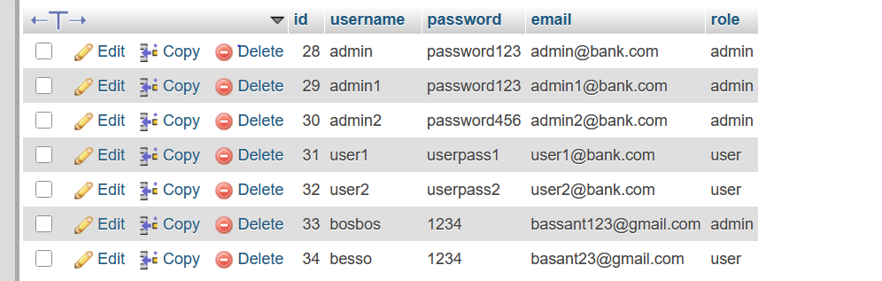
- Steps of Malicious Request / Attack and Impact
Step 1: Exploiting Weak Password Storage
- Malicious Request:
- An attacker gains access to the database.
- If passwords are stored in plaintext or with weak hashing (MD5/SHA1), the attacker can directly retrieve them.
- Impact:
- All user credentials are exposed.
- Attackers can log in to any account, including admin accounts.
- Users reusing passwords across sites may face multi-platform breaches.
- Code Before and After Fixes
Vulnerable Code (Before Fix)
Register.php
$password = $_POST['password']; // Storing in plain text (vulnerable)

Secure Code (After Fix)
// Fix: Secure password hashing
$hashedPassword = password_hash($_POST['password'], PASSWORD_BCRYPT);

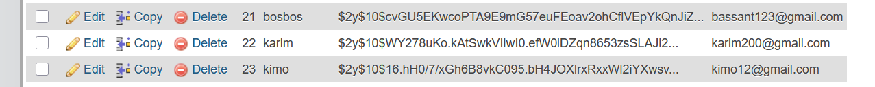
- Description of Fix
Fix 1: Secure Password Storage (Hashing + Salting)
- Implemented password_hash() with Bcrypt instead of storing plaintext passwords.
- Prevents password theft even if the database is compromised.

- OWASP Vulnerability Category & Name
- Category: A03:2021 – Injection
- Vulnerability Name: SQL Injection & Malicious Query Execution
- Description
The application is vulnerable to SQL Injection, which allows an attacker to manipulate SQL queries by injecting malicious input. This can lead to data leaks, unauthorized data modification, or even full database compromise.
Issues Identified:
- User Input Directly Injected into Queries
- Application uses user-provided values without proper sanitization, leading to SQL injection.
- No Prepared Statements in SQL Queries
- Directly concatenating user input into SQL queries makes the database vulnerable.
- Image of Beginning Request
(Screenshot of an attacker injecting SQL payloads into a login form to bypass authentication.)

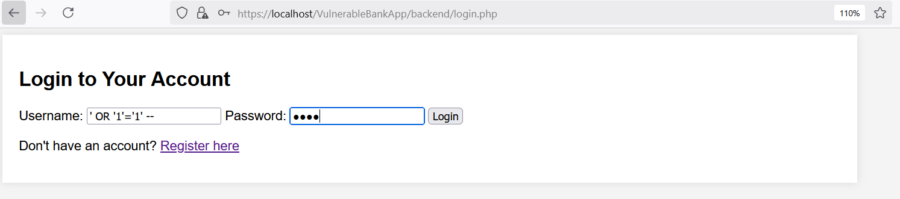

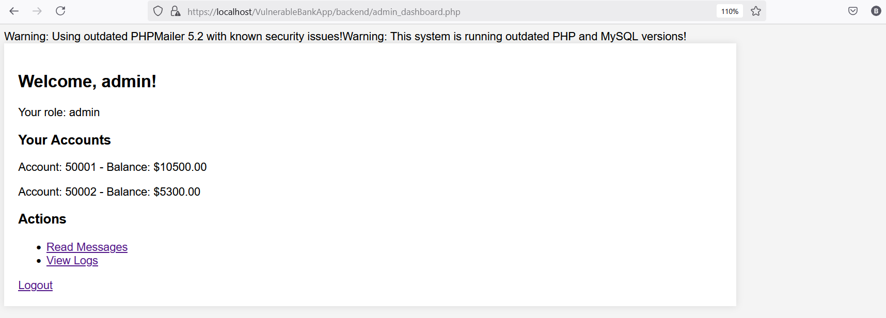
- Steps of Malicious Request / Attack and Impact
Step 1: Bypassing Login Authentication
Malicious Request:
- The attacker enters the following SQL injection payload into the username field of the login form: ' OR '1'='1' --
- If the application does not use prepared statements, the following SQL query is executed:
- Since '1'='1' always evaluates to true, the attacker logs in without valid credentials.
Impact:
- The attacker gains unauthorized access to any account, including admin accounts.
Step 2: Extracting Data from the Database
Malicious Request:
- The attacker submits the following SQL payload in a search box: ' UNION SELECT id, username, password FROM users --
- This manipulates the SQL query to expose all users’ login credentials.
Impact:
- Data leakage, allowing an attacker to access sensitive user information (emails, passwords, financial records).
Step 3: Deleting All Data
Malicious Request:
- The attacker executes: '; DROP TABLE users; --
- If the input is directly concatenated into SQL queries, the following command executes:
DELETE FROM transactions WHERE transaction_id=''; DROP TABLE users;
Impact:
- Complete database wipeout, causing permanent data loss.
- Code Before and After Fixes
Vulnerable Code (Before Fix)
Login.php
$query = "SELECT * FROM users WHERE username = '$username' AND password = '$password'";
$result = $conn->query($query);
Transfer.php
// Fetch user's accounts (Vulnerable to SQL Injection)
$query = "SELECT * FROM accounts WHERE user_id = '$user_id'";
User_dashboard.php
// SQL Injection: Direct SQL query without prepared statements
$query = "SELECT * FROM users WHERE id = '$user_id'";

Read_messages.php
// Fetch all messages (Vulnerable to SQL Injection)
$messages = $conn->query("SELECT * FROM messages");
Statement.php
// SQL Injection: Direct SQL query with user input
$query = "SELECT * FROM transactions WHERE user_id = '$user_id' ORDER BY date DESC";
$result = $conn->query($query);
Register.php
// Vulnerable SQL (no prepared statements)
$sql = "INSERT INTO users (username, email, password, role)
VALUES ('$username', '$email', '$password', '$role')";
Logs.php
// Fetch logs (Vulnerable to SQL Injection)
$query = "SELECT * FROM logs"; // Define query explicitly
Admin_dashboard.php
// Fetch user details (Vulnerable to SQL Injection)
$user_id = $_SESSION['user_id'];
$query = "SELECT * FROM users WHERE id = '$user_id'"; // Define $query explicitly

Secure Code (After Fix)
Login.php
$stmt = $conn->prepare("SELECT * FROM users WHERE username = ? AND password = ?");
$stmt->bind_param("ss", $username, $password);
$stmt->execute();
$result = $stmt->get_result();
Transfer.php
// Fetch user's accounts securely (FIXED: SQL Injection)
$query = $conn->prepare("SELECT * FROM accounts WHERE user_id = ?");
$query->bind_param("i", $user_id);
$query->execute();
$accounts = $query->get_result();
User_dashboard.php
// FIX: Use prepared statements to prevent SQL Injection
$query = $conn->prepare("SELECT * FROM users WHERE id = ?");
$query->bind_param("i", $user_id);
$query->execute();
$result = $query->get_result();
Read_messages.php
// FIX: Use prepared statements to prevent SQL Injection
$query = $conn->prepare("SELECT * FROM messages");
$query->execute();
$messages = $query->get_result();
Statement.php
// FIX: Use prepared statements to prevent SQL Injection
$query = $conn->prepare("SELECT * FROM transactions WHERE user_id = ? ORDER BY date DESC");
$query->bind_param("i", $user_id);
$query->execute();
$result = $query->get_result();
Register.php
// FIX: Use prepared statements to prevent SQL Injection
$sql = $conn->prepare("INSERT INTO users (username, email, password, role) VALUES (?, ?, ?, ?)");
$sql->bind_param("ssss", $username, $email, $password, $role);
if ($sql->execute()) {
$message = "Registration successful! <a href='login.php'>Login</a>";
} else {
Logs.php
// FIX: Use a prepared statement to prevent SQL Injection
$sql = $conn->prepare("SELECT * FROM logs");
$sql->execute();
$logs = $sql->get_result();
Admin_dashboard.php
// FIX: Use a prepared statement to prevent SQL Injection
$user_id = $_SESSION['user_id'];
$sql = $conn->prepare("SELECT * FROM users WHERE id = ?");
$sql->bind_param("i", $user_id); // Bind user ID securely as an integer
$sql->execute();
$result = $sql->get_result();

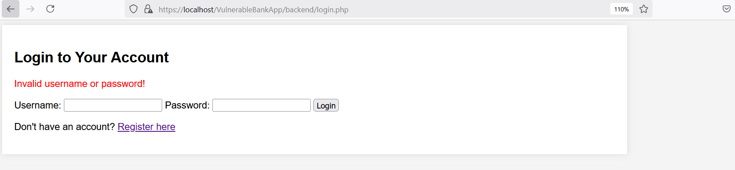
- Description of Fix
Fix 1: Use Prepared Statements to Prevent SQL Injection
- Instead of directly embedding user input into SQL queries, prepared statements are used.
- Prepared statements ensure that user inputs are treated as data, not executable SQL code.
Fix 2: Parameterized Queries to Secure User Inputs
- Replaced vulnerable queries with parameterized queries, binding user inputs as parameters instead of embedding them directly in SQL statements.
- Prevents attackers from injecting malicious SQL payloads.
Fix 3: Secure User Registration to Prevent SQL Injection
- The previous implementation allowed injection attacks when creating a new user.
- Using prepared statements ensures that username, email, password, and role inputs are securely handled.
Fix 4: Secure Data Fetching from Logs and Messages
- The application previously queried logs and messages without protection, allowing SQL injection attacks.
- By removing direct user input from queries and using prepared statements, data retrieval is now secure.
Fix 5: Prevent Database Destruction (SQL Injection Protection)
- SQL injection attacks like '; DROP TABLE users; -- could delete entire tables.
- Using prepared statements prevents such malicious queries from executing.

- OWASP Vulnerability Category & Name
- Category: A04:2021 – Insecure Design
- Vulnerability Name: Weak Authentication & Authorization Design
- Description
The application lacks proper role-based access control (RBAC) and secure authentication mechanisms. Several pages allow unauthorized access or expose sensitive data due to missing or weak validation of user roles.
Key vulnerabilities include:
- Missing Admin Check: Any authenticated user can access sensitive admin-only pages (e.g., logs, complaints, and user details).
- Lack of Input Validation: The system does not validate roles upon login, allowing users to impersonate admins.
- Exposing SQL Errors: Raw database errors are displayed, revealing system details to attackers.
- No Transaction Control: Money transfers lack atomic operations, leading to potential financial inconsistencies.
- Missing Pagination & Rate Limiting: Fetching all messages or transactions at once causes performance issues and opens doors to denial-of-service (DoS) attacks.
- Image of Beginning Request
(screenshot of unauthenticated admin (user) can view logs.php.)
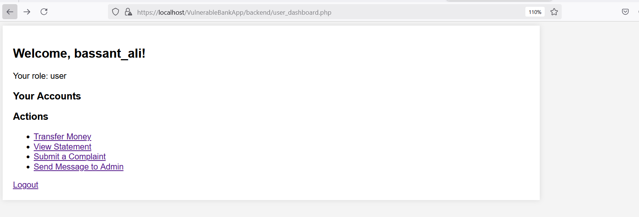
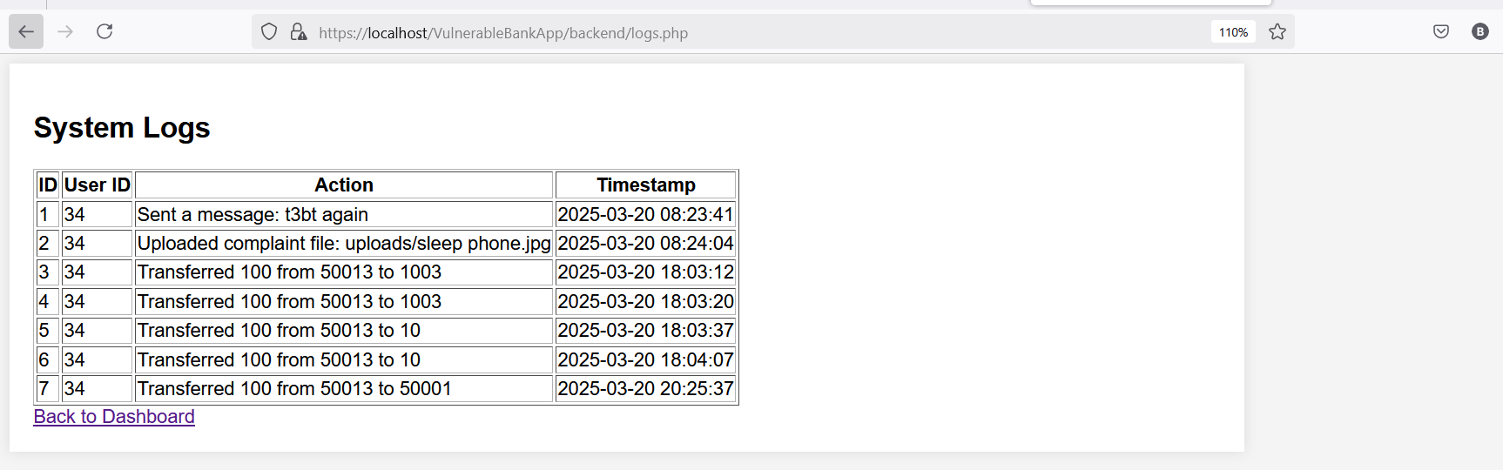
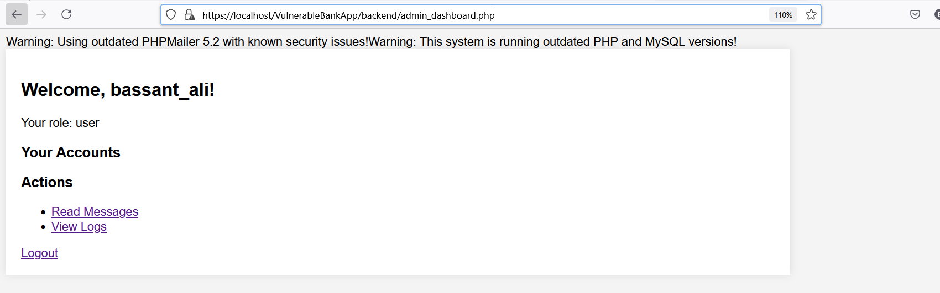
(screenshot after deleting admin3 still can get to logs.php)
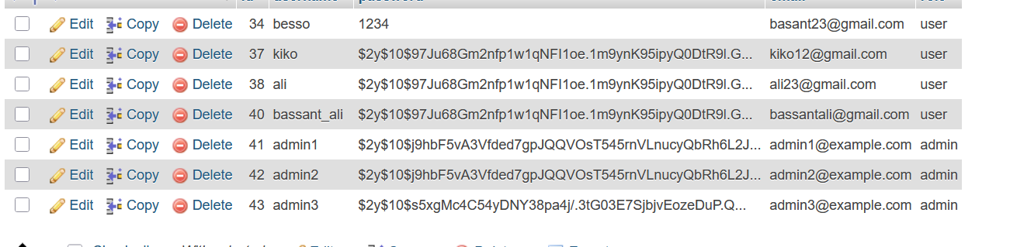
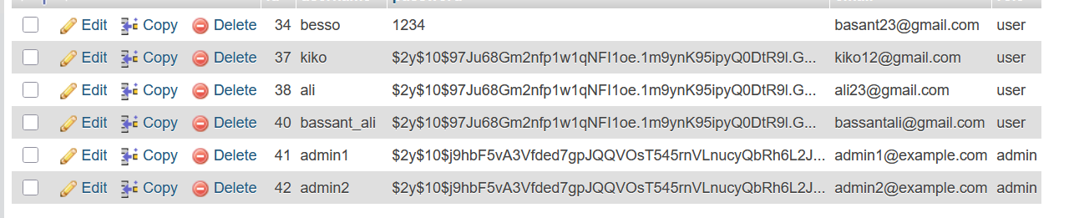

- Steps of Malicious Request / Attack and Impact
Step 1: Unauthorized Log Access
Malicious Request
- A normal user logs into their account.
- They manually enter logs.php in the browser.
- The page loads sensitive system logs without verifying admin privileges.
Impact:
- Exposure of system logs (could contain sensitive user data or security events).
- Attackers can learn about database structure from error logs.
Step 2: Role Manipulation on Registration
Malicious Request
- A user intercepts the request during registration and modifies the role field:
POST /register.php HTTP/1.1
Content-Type: application/x-www-form-urlencoded

username=hacker&password=123456&role=admin
- The user is now registered as an admin.
Impact:
- A normal user gains admin privileges.
- They can access and modify sensitive data.
Step 3: SQL Injection via Log Messages
Malicious Request
- The attacker sends a malicious log entry:
POST /messages.php HTTP/1.1
Content-Type: application/x-www-form-urlencoded

message=Hello!'); DROP TABLE users; --
- The system stores this in logs without sanitization.
- When an admin views the logs, the SQL command executes, deleting all users.
Impact:
- Loss of critical database tables.
- Attackers can inject harmful queries into logs.

- Code Before and After Fixes
Vulnerable Code
register.php
$role = $_POST['role']; // Allow users to select role (vulnerable)

Admin_dashboard.php
// Issue (A04:2021 – Insecure Design): No Role-Based Access Control (RBAC)
// Any authenticated user can access user details. Admin check was removed.
if (!isset($_SESSION['user_id'])) {
die("Unauthorized access! <a href='login.php'>Login</a>");
}
Complaints.php
// Issue (A04:2021 – Insecure Design): No Role-Based Access Control (RBAC)
// Any logged-in user can upload complaints without permission checks.
if (!isset($_SESSION['user_id'])) {
die("Unauthorized access! <a href='login.php'>Login</a>");
}

// Issue: Logs file name without sanitization (Sensitive data exposure)
$conn->query("INSERT INTO logs (user_id, action, timestamp)
VALUES ('$user_id', 'Uploaded complaint file: $file_path', NOW())");
Logs.php
// Issue (A04:2021 – Insecure Design): No admin check
// Any logged-in user can access system logs, which should be restricted.
if (!isset($_SESSION['user_id'])) {
die("Unauthorized access! <a href='login.php'>Login</a>");
}

// Issue (A04:2021 – Insecure Design): No Role-Based Access Control (RBAC)
// The system does not verify if the user is an admin.
$sql = $conn->prepare("SELECT * FROM logs");
$sql->execute();
$logs = $sql->get_result();
Messages.php
// Issue (A04:2021 – Insecure Design): No verification if user_id exists in the database
// If the user was deleted, their session still allows sending messages
// Issue (A04:2021 – Insecure Design): No rate limiting or message length validation
// This allows unlimited messages of any size to be sent, causing potential spam or DoS
$conn->query("INSERT INTO messages (user_id, message) VALUES ('$user_id', '$user_message')");
// Log the message sending action
// Issue: Logs raw user input, making logs vulnerable to injection or log pollution
$conn->query("INSERT INTO logs (user_id, action, timestamp)
VALUES ('$user_id', 'Sent a message: $user_message', NOW())");
Read_messages.php
// Issue (A04:2021 – Insecure Design): No access control verification
// The system assumes the session user_id exists in the database without checking
// FIX: Use prepared statements to prevent SQL Injection
// Issue (A04:2021 – Insecure Design): No pagination or rate limiting
// This query fetches ALL messages, which could lead to performance issues or DoS attacks
$query = $conn->prepare("SELECT * FROM messages");
$query->execute();
$messages = $query->get_result();
Statements.php
// Issue (A04:2021 – Insecure Design): No access control verification
// The system assumes the session user_id exists in the database
// FIX: Use prepared statements to prevent SQL Injection
// Issue (A04:2021 – Insecure Design): No pagination or rate limiting
// This query fetches ALL transactions, which could lead to performance issues or DoS attacks
$query = $conn->prepare("SELECT * FROM transactions WHERE user_id = ? ORDER BY date DESC");
$query->bind_param("i", $user_id);
$query->execute();
$result = $query->get_result();
Transfer.php
// Issue (A04:2021 – Insecure Design): No transaction wrapping
$to_account_check = $conn->query("SELECT * FROM accounts WHERE account_number = '$to_account'");

// Issue (A04:2021 – Insecure Design): No rate limiting on transfers
// Issue: No error handling if balance update fails
// Step 3: Check if the 'from_account' has sufficient balance
$from_account_data = $from_account_result->fetch_assoc();

// Issue (A04:2021 – Insecure Design): No transaction control (money might be deducted but not added)
// Log the transaction (securely using session user_id)
$conn->query("INSERT INTO transactions (user_id, from_account, to_account, amount, type, date)
VALUES ('$user_id', '$from_account', '$to_account', '$amount', 'transfer', NOW())");
User_dashboard.php
// Issue (A04:2021 – Insecure Design): Any authenticated user can access user details
if (!isset($_SESSION['user_id'])) {
die("Unauthorized access! <a href='login.php'>Login</a>");
}

Login.php
$_SESSION['role'] = $user['role']; // A04:2021 – Insecure Design: Directly trusting role from DB

if ($user['role'] == 'admin') { // A04:2021 – Insecure Design: No validation of role integrity

Secure Code
Register.php
// Fix: Prevent users from selecting their own role
$role = 'user'; // Default role assignment
Login.php
// FIXED: Validate and enforce role assignment securely
$allowed_roles = ['admin', 'user']; // Define allowed roles
if (!in_array($user['role'], $allowed_roles)) {
// Invalid role detected, default to 'user'
$_SESSION['role'] = 'user';
} else {
$_SESSION['role'] = $user['role']; // Securely assign role
}

// FIXED: Enforce strict admin access check
if ($_SESSION['role'] === 'admin') {
header("Location: admin_dashboard.php");
} else {
header("Location: user_dashboard.php");
}
Admin_dashboard.php
// Fix: Implement Role-Based Access Control (RBAC)
// Only allow access if the user is an admin.
if (!isset($_SESSION['user_id']) || $_SESSION['role'] !== 'admin') {
die("Unauthorized access! Admins only. <a href='login.php'>Login</a>");
}
Logs.php
// Fix: Implement Role-Based Access Control (RBAC)
if (!isset($_SESSION['user_id']) || $_SESSION['role'] !== 'admin') {
die("Unauthorized access! <a href='login.php'>Login</a>");
}

// Fetch user role securely
$user_id = $_SESSION['user_id'];
$role_check = $conn->prepare("SELECT role FROM users WHERE id = ?");
$role_check->bind_param("i", $user_id);
$role_check->execute();
$result = $role_check->get_result();
$user = $result->fetch_assoc();

// Now, only admins can access logs
$sql = $conn->prepare("SELECT * FROM logs");
$sql->execute();
$logs = $sql->get_result();
Message.php
// Fix: Verify if the user_id exists in the database
$result = $conn->query("SELECT id FROM users WHERE id = '$user_id'");
if ($result->num_rows === 0) {
die("Unauthorized access! User does not exist.");
}

// Fix: Enforce message length limit (e.g., 500 characters)
if (strlen($user_message) > 500) {
die("Message is too long. Maximum 500 characters allowed.");
}
// Fix: Implement basic rate limiting (prevent spamming)
$last_message = $conn->query("SELECT timestamp FROM messages WHERE user_id = '$user_id' ORDER BY timestamp DESC LIMIT 1");
if ($last_message->num_rows > 0) {
$row = $last_message->fetch_assoc();
$last_time = strtotime($row['timestamp']);
if (time() - $last_time < 10) { // Enforce 10-second delay between messages
die("Please wait before sending another message.");
}
}
Read_messages.php
// Fix: Verify if user_id exists in the database to prevent stale sessions
$checkUser = $conn->prepare("SELECT id FROM users WHERE id = ?");
$checkUser->bind_param("i", $_SESSION['user_id']);
$checkUser->execute();
$result = $checkUser->get_result();
if ($result->num_rows === 0) {
die("Unauthorized access! User does not exist.");
}
// ✅ Fix: Implement pagination to prevent excessive data retrieval
$limit = 10; // Number of messages per page
$page = isset($_GET['page']) ? (int) $_GET['page'] : 1;
$offset = ($page - 1) * $limit;
$query = $conn->prepare("SELECT * FROM messages LIMIT ? OFFSET ?");
$query->bind_param("ii", $limit, $offset);
Statement.php
// Fix: Verify if user_id exists in the database to prevent stale sessions
$checkUser = $conn->prepare("SELECT id FROM users WHERE id = ?");
$checkUser->bind_param("i", $user_id);
$checkUser->execute();
$result = $checkUser->get_result();
if ($result->num_rows === 0) {
die("Unauthorized access! User does not exist.");
}
// Fix: Implement pagination to prevent excessive data retrieval
$limit = 10; // Number of transactions per page
$page = isset($_GET['page']) ? (int) $_GET['page'] : 1;
$offset = ($page - 1) * $limit;
$query = $conn->prepare("SELECT * FROM transactions WHERE user_id = ? ORDER BY date DESC LIMIT ? OFFSET ?");
$query->bind_param("iii", $user_id, $limit, $offset);

Transfer.php
// Fix: Implement transaction control to prevent inconsistent money transfers
$conn->begin_transaction();

// Fix: Ensure transaction and logs are committed together
$insert_transaction = $conn->prepare("INSERT INTO transactions (user_id, from_account, to_account, amount, type, date)
VALUES (?, ?, ?, ?, 'transfer', NOW())");
$insert_transaction->bind_param("issd", $user_id, $from_account, $to_account, $amount);
$insert_transaction->execute();
$insert_log = $conn->prepare("INSERT INTO logs (user_id, action, timestamp)
VALUES (?, ?, NOW())");
$log_message = "Transferred $amount from $from_account to $to_account";
$insert_log->bind_param("is", $user_id, $log_message);
$insert_log->execute();
// Fix: Ensure transaction is committed only if all queries succeed
$conn->commit();
$message = "Transfer successful!";
} catch (Exception $e) {
// Fix: Rollback if any query fails to prevent partial money transfer
$conn->rollback();
$message = $e->getMessage();
}
User_dashboard.php
// FIX: Implement Role-Based Access Control (RBAC) to restrict access
if (!isset($_SESSION['user_id']) || $_SESSION['role'] !== 'user') {
die("Unauthorized access! <a href='login.php'>Login</a>");
}

- Description of Fixes
Fix 1: Implement Role-Based Access Control (RBAC)
- Implemented role checks before granting access to sensitive pages such as Admin_dashboard.php, Logs.php, and Complaints.php.
- Only users with the admin role can access system logs and admin functionalities.
- Prevents unauthorized users from performing administrative actions.
Fix 2: Restrict Role Assignment During Registration
- Instead of allowing users to select their own role ($role = $_POST['role'];), the system now assigns the default role of user upon registration.
- Prevents privilege escalation attacks where users can register as administrators.
Fix 3: Enforce Access Control on Sensitive Endpoints
- Added verification to check if the user_id in the session exists in the database before allowing actions in Messages.php, Read_messages.php, Statements.php, and User_dashboard.php.
- Ensures that deleted users cannot continue performing actions.
Fix 4: Secure Log Storage to Prevent Sensitive Data Exposure
- Previously, logs stored file paths and raw user inputs without sanitization, exposing sensitive data.
- Implemented sanitization and stored only necessary information in logs to prevent information leaks.
Fix 5: Secure Complaints Upload with Permission Checks
- Added role-based access control to Complaints.php to ensure that only authorized users can upload complaints.
- Implemented input validation and sanitization to prevent malicious file uploads.
Fix 6: Implement Rate Limiting on Messages and Transfers
- Implemented rate limiting to restrict the number of messages a user can send in a short time, preventing spam and DoS attacks
- Added transaction limits to Transfer.php to prevent users from rapidly initiating multiple money transfers.
Fix 7: Validate User Role Integrity After Login
- Instead of directly trusting the role stored in the database, the system now verifies the integrity of user roles.
- Prevents unauthorized privilege escalation through session manipulation.
Fix 8: Implement Secure Logging Practices
- Previously, log files recorded raw user input, making them vulnerable to log pollution attacks.
- Sanitized user inputs before logging and implemented structured logging to prevent injection-based attacks.
Fix 9: Secure Database Queries with Prepared Statements
- Replaced direct SQL queries with prepared statements to prevent SQL injection.
- Ensured that all user inputs are properly sanitized and bound to queries securely.

- OWASP Vulnerability Category & Name
- Category: A05:2021 – Security Misconfiguration
- Vulnerability Name: Exposing Detailed Error Messages

Description

The application is vulnerable to security misconfigurations, specifically due to the exposure of detailed error messages. This occurs when the application reveals stack traces or other overly informative error messages to the user, which can give attackers valuable insights into the inner workings of the system. Detailed error messages should be handled properly to avoid exposing sensitive information such as database errors, file paths, or other internal system details.
Issues Identified:
- Exposing Detailed Error Messages: The application reveals detailed error messages to users, including SQL errors, file paths, and system versions. This exposes critical information that attackers can use to gain further access to the system or escalate their attacks.
- Outdated and Vulnerable Components: The application uses outdated and vulnerable libraries (e.g., PHPMailer, jQuery) without proper validation, which may lead to security risks such as Cross-Site Scripting (XSS) or Remote Code Execution (RCE).
- Image of Beginning Request
(Screenshot of login or dashboard page showing database errors due to incorrect credentials or a failed query.)
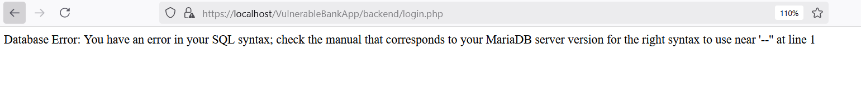
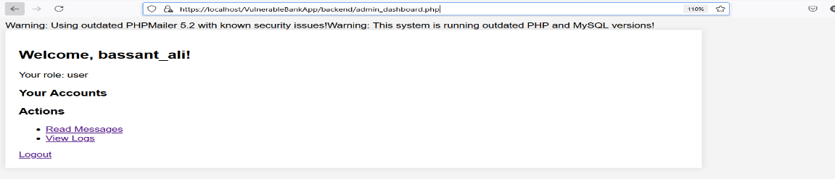
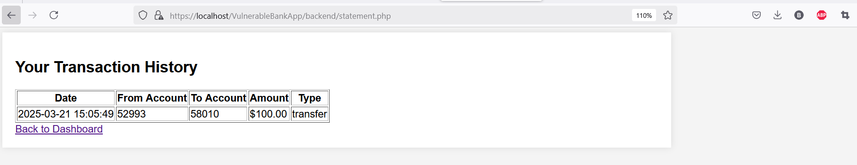
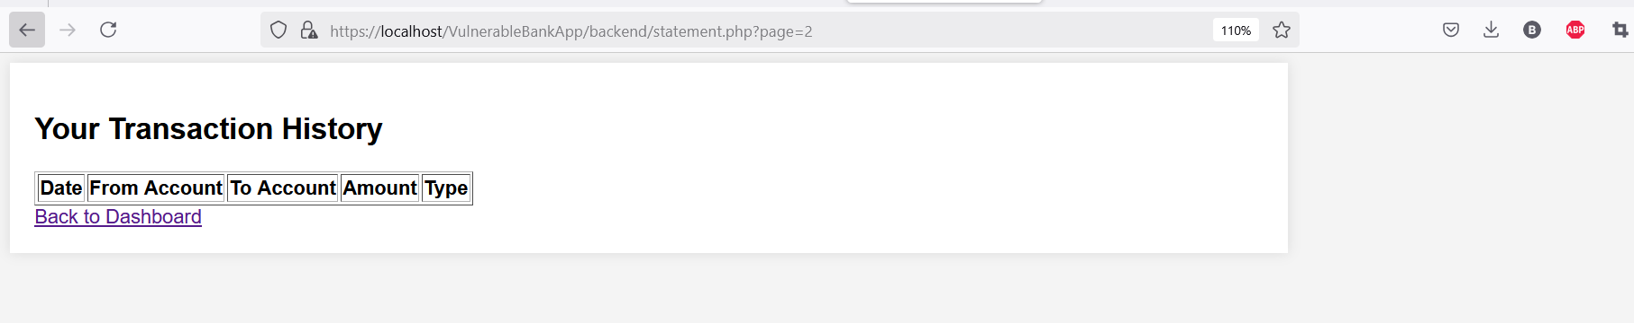
- Steps of Malicious Request / Attack and Impact
Step 1: Exposing Sensitive Information in Error Messages
Malicious Request:
- An attacker triggers an error by making invalid requests or exploiting weak validation (e.g., submitting a bad SQL query or uploading a dangerous file).
- The application responds by revealing detailed error messages, such as database errors, file paths, or system version information.
Impact:
Attackers gain information about the database structure, server paths, or vulnerable components (e.g., outdated PHPMailer version), which they can use to refine their attacks and gain unauthorized access.
Step 2: Exposing Outdated Libraries
Malicious Request:
- The attacker notices the use of outdated libraries (e.g., jQuery 1.4.2) and exploits known vulnerabilities in these versions (such as XSS vulnerabilities).
Impact:
Attackers can perform cross-site scripting (XSS) attacks, injecting malicious scripts into the application and compromising user data or session information.
Step 3: Uploading a Malicious PHP Shell in Submit Complaint Page
Malicious Request:
- The attacker submits a complaint and uploads a file named shell.php containing:
<?php system($_GET['cmd']); ?>
- The upload is successful, and the attacker accesses it via:
http://example.com/uploads/shell.php?cmd=whoami
Impact:
- The attacker can execute system commands, gaining unauthorized access to the server.
- They can read, modify, or delete files on the system.
- The server can be used as a launching point for further attacks.
- Code Before and After Fixes
Vulnerable Code (Before Fix)
Admin_dashboard.php
// Security Misconfiguration: Using an outdated and vulnerable PHPMailer version
// Simulating an outdated library inclusion (Deprecated PHPMailer)
@require 'PHPMailer-5.2/PHPMailerAutoload.php'; // Suppress error to simulate outdated component use // Uses an outdated and vulnerable PHPMailer version

// Security Misconfiguration: Revealing system version information to attackers
echo "Warning: This system is running outdated PHP and MySQL versions!";

if (!$result) {
// Security Misconfiguration: Exposing detailed SQL error messages
echo "Error fetching user: " . $conn->error;
}

// Security Misconfiguration: Using an outdated and vulnerable JavaScript library
// Use an outdated JavaScript library (vulnerable to XSS)
echo '<script src="https://code.jquery.com/jquery-1.4.2.min.js"></script>';
echo '<script>alert("Warning: This page is using an outdated jQuery version (1.4.2), which has known security vulnerabilities!");</script>';
Complaints.php
$upload_dir = "uploads/"; // No file type validation - Attackers can upload executable scripts
$file_path = $upload_dir . basename($file["name"]);

// Security Misconfiguration: Logging file name without sanitization (Potential data exposure)
$conn->query("INSERT INTO logs (user_id, action, timestamp)
VALUES ('$user_id', 'Uploaded complaint file: $file_path', NOW())");
Logs.php
// Issue: Expose SQL error to the user (Security Misconfiguration)
echo "Error fetching logs: " . $conn->error;
Messages.php
// Issue: Logs raw user input, making logs vulnerable to injection or log pollution
$conn->query("INSERT INTO logs (user_id, action, timestamp)
VALUES ('$user_id', 'Sent a message:
$user_message', NOW())");
Register.php
// A05:2021 – Security Misconfiguration
$username = $_POST['username']; // No validation
$email = $_POST['email']; // No validation
$role = $_POST['role']; // Allow users to select role (vulnerable)

$message = "Error: " . $conn->error; // Leaks database errors (vulnerable)
Transfer.php
// issue: Exposing detailed error messages
if (!$accounts) {
// Exposing internal database error details
echo "Error fetching accounts: " . $conn->error; // Reveals detailed DB error
exit;
}
User_dashboard.php
if (!$result) {
// Issue: Exposes detailed SQL error to the user (Security Misconfiguration)
echo "Error fetching user: " . $conn->error;
}

Secure Code (After Fix)
Admin_dashboard.php
// Warning about outdated software
// Security Misconfiguration: Revealing system version information to attackers
//echo "Warning: This system is running outdated PHP and MySQL versions!";

// Fix: Security Misconfiguration: Exposing detailed SQL error messages
echo "Error fetching user data. Please try again later.";
Complaints.php
// Validate file type before upload to avoid malicious scripts
$allowed_types = ['image/jpeg', 'image/png', 'application/pdf']; // Allow only certain file types
if (!in_array($file['type'], $allowed_types)) {
die("Invalid file type. Only JPG, PNG, and PDF files are allowed.");
}

// Avoid file name issues and sanitize inputs
$safe_file_name = preg_replace("/[^a-zA-Z0-9\._-]/", "_", basename($file["name"]));

// Fix: Sanitize the file name to prevent dangerous characters
$upload_dir = "uploads/";
$safe_file_name = preg_replace("/[^a-zA-Z0-9\._-]/", "_", basename($file["name"]));
$file_path = $upload_dir . $safe_file_name;
Logs.php
if (!$logs) {
// Fix: Do not expose SQL error details to the user
echo "An error occurred while fetching logs. Please try again later.";
}
messages.php
// Fix: Sanitize user input before logging to prevent injection and log pollution
$sanitized_message = $conn->real_escape_string($user_message); // Sanitize user message for safe logging
$conn->query("INSERT INTO logs (user_id, action, timestamp)
VALUES ('$user_id', 'Sent a message: $sanitized_message', NOW())");
Register.php
// Fix: Input validation and sanitization
$username = filter_var(trim($_POST['username']), FILTER_SANITIZE_STRING);
$email = filter_var(trim($_POST['email']), FILTER_VALIDATE_EMAIL)
// Fix: Generic error message to prevent information disclosure
$message = "Registration failed. Please try again later.";
Transfer.php
// Fix: Hide internal database error details
if (!$accounts) {
die("Error retrieving account information. Please try again later.");
}
User_dashboard.php
if (!$result) {
// FIX: Hide detailed database errors from users
die("An error occurred. Please try again later."); // Show generic error message
}

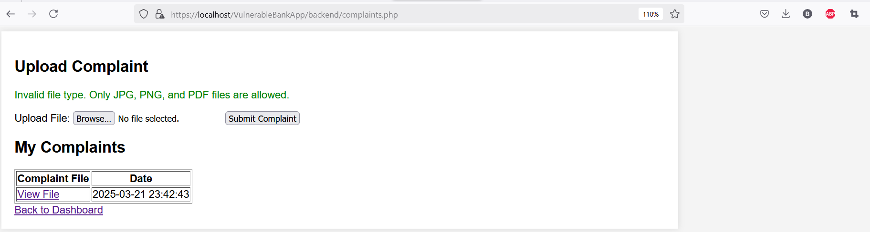
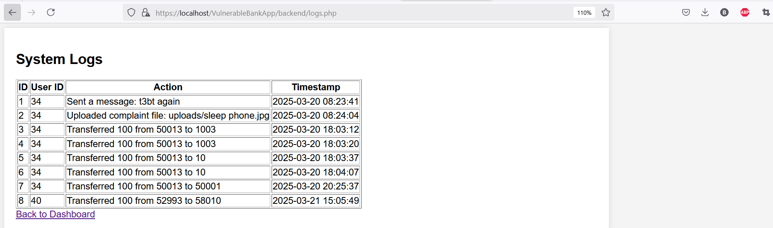
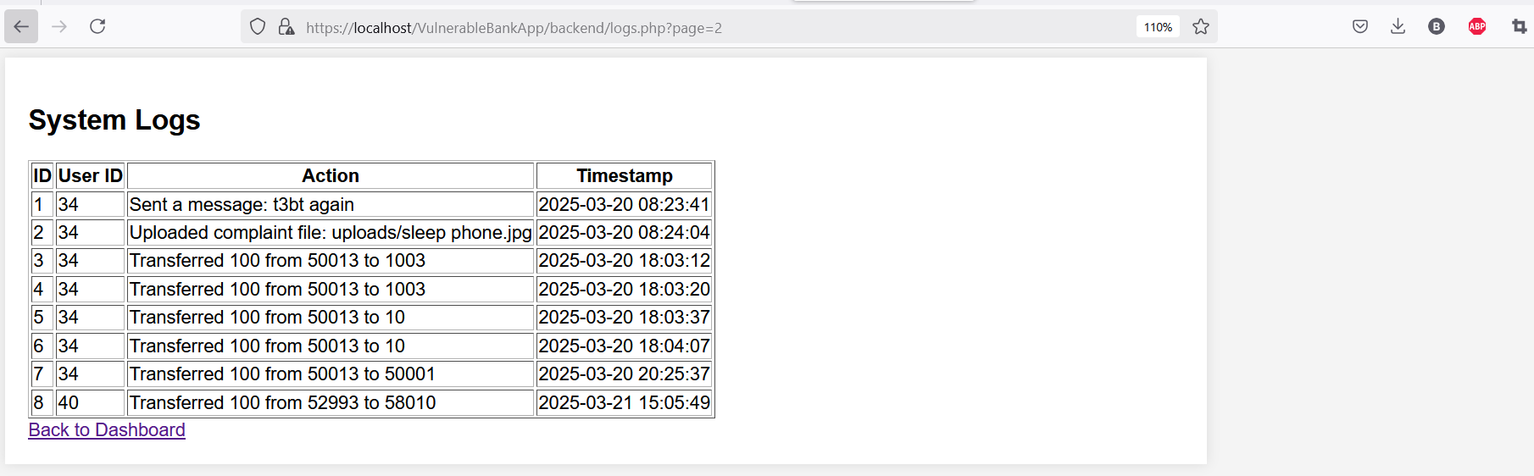

- Description of Fixes
Fix 1: Implement Generic Error Messages to Prevent Information Disclosure
- Replaced detailed database error messages with generic ones to prevent attackers from gaining insights into the system.
- Removed direct output of SQL errors from Admin_dashboard.php, Transfer.php, and User_dashboard.php.
- Prevents attackers from using exposed SQL errors to craft further attacks.
Fix 2: Secure File Uploads to Prevent Arbitrary Code Execution
- Implemented strict file type validation in Complaints.php, allowing only JPG, PNG, and PDF formats.
- Sanitized file names to prevent special characters that could be used for path traversal attacks.
- Prevents attackers from uploading malicious scripts (e.g., PHP shells) and executing arbitrary commands.
Fix 3: Sanitize User Inputs Before Logging
- Applied input sanitization to prevent log injection attacks in Messages.php.
- Used real_escape_string to ensure that logs do not store raw user inputs, preventing log pollution attacks.
- Ensures logs remain reliable and protected from injection-based exploits.
Fix 4: Restrict Role Assignment During Registration
- Removed the ability for users to select their role in Register.php. Instead, all new users are assigned the default role of user.
- Prevents privilege escalation attacks where users could register as an administrator.
Fix 5: Prevent Exposure of Internal System Information
- Removed warnings about outdated PHP and MySQL versions from Admin_dashboard.php.
- Ensured that system information is not leaked to users via alert messages or debug outputs.
- Prevents attackers from gaining insights into the system’s underlying technologies.
Fix 6: Secure Logging Practices to Prevent Sensitive Data Exposure
- Removed direct logging of sensitive user actions in Logs.php without sanitization.
- Implemented structured logging to store only necessary details, avoiding raw user input storage.
- Prevents exposure of sensitive user actions and potential data leaks.

- OWASP Vulnerability Category & Name
- Category: A06:2021 – Vulnerable and Outdated Components
- Vulnerability Name: Use of Outdated Libraries (PHPMailer & jQuery)
- Description
The application suffers from the use of outdated and vulnerable components, including outdated versions of PHPMailer and jQuery, which expose it to known security flaws such as remote code execution, XSS attacks, and unauthorized access.
Issues Identified:
- Use of an Outdated PHPMailer Library (Version 5.2): The application includes an obsolete version of PHPMailer that contains known security vulnerabilities, allowing attackers to exploit remote code execution (RCE) flaws.
- Use of an Outdated jQuery Library (Version 1.4.2): The application loads an old version of jQuery that contains cross-site scripting (XSS) vulnerabilities, which attackers can use to execute malicious scripts in a user's browser.
- Image of Beginning Request
(Screenshot of old PHP version output or error messages)
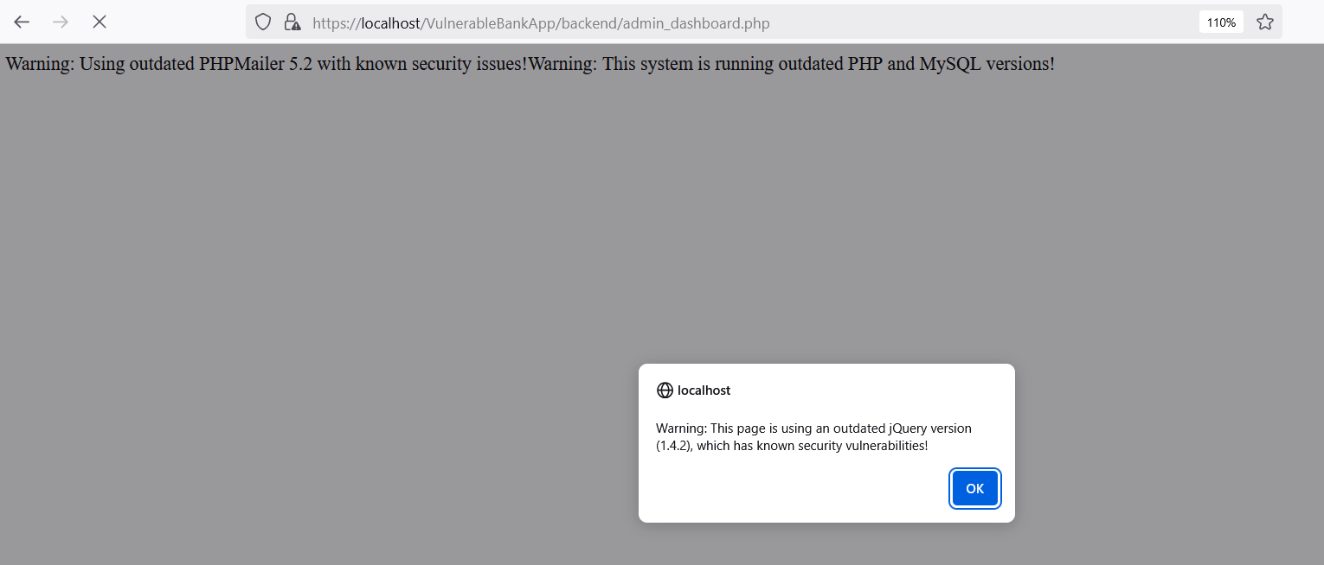

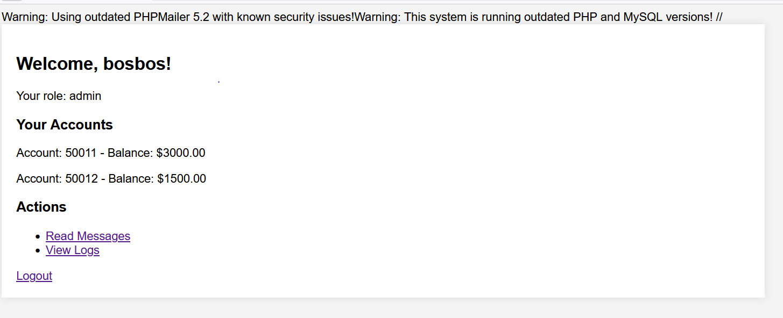

- Steps of Malicious Request / Attack and Impact
Step 1: Exploiting an Outdated PHPMailer Version
Malicious Request:
- An attacker exploits the remote code execution (RCE) vulnerability in the outdated PHPMailer library by sending a specially crafted email payload.
- The payload injects malicious shell commands that the server executes.
Impact:
- The attacker gains full control of the server, leading to: Remote Code Execution (RCE), Data theft or manipulation, Server compromise
Step 2: Exploiting an Outdated jQuery Version
Malicious Request:
- An attacker injects a malicious XSS payload into an input field.
- Due to vulnerabilities in jQuery 1.4.2, the script is executed when a user visits the affected page.
Impact:
- The attacker can: Steal session cookies, Perform actions on behalf of the user, Redirect users to malicious websites
- Code Before and After Fixes
Vulnerable Code (Before Fix)
Admin_dashboard.php
// Simulating an outdated library inclusion (Deprecated PHPMailer)
@require 'PHPMailer-5.2/PHPMailerAutoload.php'; // Suppress error to simulate outdated component use // ❌ Uses an outdated and vulnerable PHPMailer version

// Use an outdated JavaScript library (vulnerable to XSS)
echo '<script src="https://code.jquery.com/jquery-1.4.2.min.js"></script>';
echo '<script>alert("Warning: This page is using an outdated jQuery version (1.4.2), which has known security vulnerabilities!");</script>';

Secure Code (After Fix)
Admin_dashboard.php
// Fix: Update PHPMailer to a secure and supported version
use PHPMailer\PHPMailer\PHPMailer;
use PHPMailer\PHPMailer\Exception;
require __DIR__ . '/vendor/autoload.php'; // Ensure correct path
$mail = new PHPMailer(true); // Use PHPMailer with exception handling

// Fix: Use a secure and up-to-date JavaScript library
echo '<script src="https://code.jquery.com/jquery-3.6.0.min.js"></script>';
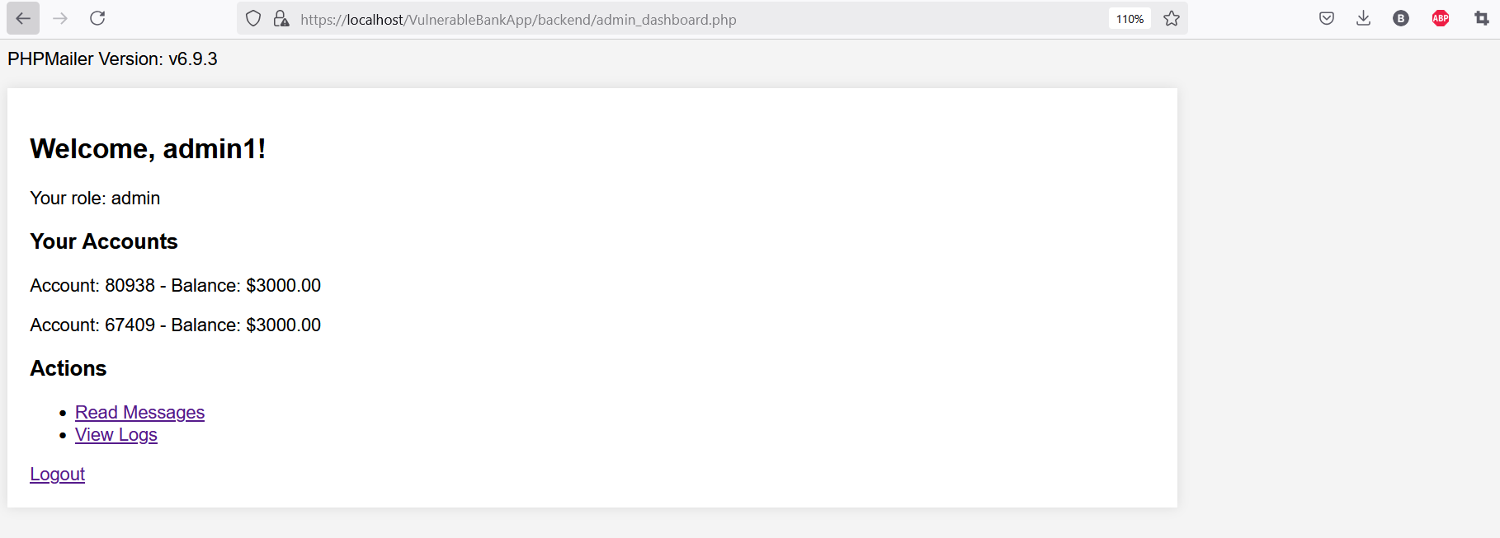

- Description of Fixes
Fix 1: Update PHPMailer to a Secure Version
- Removed the outdated PHPMailer 5.2 and replaced it with the latest stable version using Composer:
composer require phpmailer/phpmailer
- Implemented exception handling for secure email handling.
Fix 2: Use a Secure jQuery Version
- Replaced jQuery 1.4.2 with jQuery 3.6.0, which fixes multiple XSS vulnerabilities.

- OWASP Vulnerability Category & Name
- Category: A07:2021 – Identification and Authentication Failures
- Vulnerability Name: Weak Authentication Mechanisms and Session Management Flaws
- Description
The application suffers from identification and authentication failures, allowing attackers to bypass authentication mechanisms, hijack user sessions, or exploit weak credential management practices.
Issues Identified:
- Weak Password Policies:
- The system allows users to set weak passwords without complexity requirements.
- Insecure Login Mechanism:
- The login process does not implement proper brute-force protection.
- The system does not use secure password hashing mechanisms.
- Session Hijacking via Predictable Session IDs:
- The application generates predictable session tokens, making it easy for attackers to hijack user sessions.
- Exposed Authentication Data in URLs:
- User authentication tokens are passed in the URL, allowing attackers to steal credentials from logs or browser history.
- Image of Beginning Request
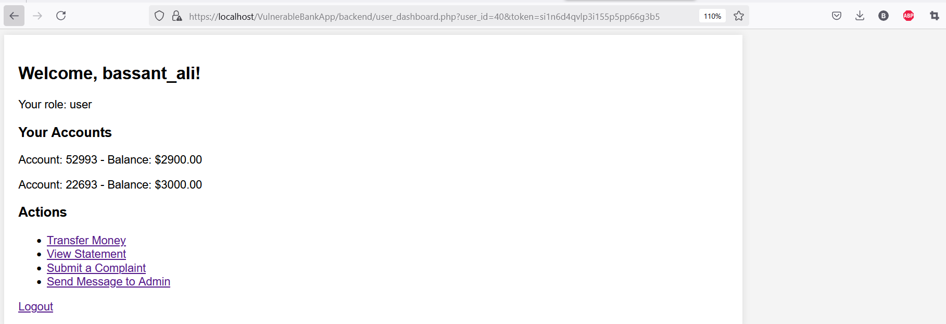
- Steps of Malicious Request / Attack and Impact
Step 1: Exploiting Weak Password Policies
Malicious Request:
- A user sets their password as "123456" or "password", which lacks complexity requirements.
- An attacker uses a dictionary attack to guess the weak password.
Impact:
- Account compromise, leading to: Unauthorized access, Data theft, Manipulation of sensitive information

Step 2: Brute-Force Attack on Login
Malicious Request:
- An attacker repeatedly tries different username/password combinations without being blocked.
Impact:
- The attacker successfully logs into accounts by exploiting the lack of rate limiting or CAPTCHA protection.
Step 3: Session Hijacking via Predictable Session IDs
Malicious Request:
- The system generates session tokens using a simple pattern (SESSIONID12345).
- An attacker predicts and steals another user’s session, bypassing authentication.
Impact:
- Session takeover, allowing unauthorized access to user accounts without needing credentials.
Step 4: Credential Exposure in URL
Malicious Request:
- The login request appends credentials or session tokens to the URL:
https://localhost/VulnerableBankApp/backend/user_dashboard.php?user_id=40&token=si1n6d4qvlp3i155p5pp66g3b5
- The attacker retrieves credentials from browser history, logs, or referrer headers.
Impact:
- Credentials leakage, allowing unauthorized access.
- Code Before and After Fixes
Vulnerable Code (Before Fix)
Login.php
// No failed login attempt logging (Brute-force attack possible)
$stmt = $conn->prepare("SELECT id, username, role, password FROM users WHERE username = ?");
$stmt->bind_param("s", $username);
$stmt->execute();
$result = $stmt->get_result();

// Password hashing, but session security is weak
if (password_verify($password, $user['password'])) {
$_SESSION['user_id'] = $user['id'];
$_SESSION['username'] = $user['username'];
// Role assignment without strong validation
$_SESSION['role'] = (in_array($user['role'], ['admin', 'user'])) ? $user['role'] : 'user';
// No session regeneration
if ($_SESSION['role'] === 'admin') {
// Authentication token passed in URL (Exposed in logs, browser history)
header("Location: admin_dashboard.php?user_id=" . $_SESSION['user_id'] . "&token=" . session_id());
} else {
// Authentication token exposed in URL
header("Location: user_dashboard.php?user_id=" . $_SESSION['user_id'] . "&token=" . session_id());
}

// No brute-force protection (Attacker can keep guessing passwords)
$error = "Invalid username or password!";
Register.php
$password = $_POST['password']; // Plaintext password, no validation

// Missing email validation, could allow invalid or malicious input
if (!$email) {
die("Invalid email format!");
}

// No password complexity validation, allows weak passwords
// Storing passwords in plaintext, making them vulnerable to leaks
$password = password_hash($password, PASSWORD_BCRYPT);
// Users can set their own roles, which is a security risk
$role = $_POST['role'];
// No check for duplicate usernames/emails
$sql = $conn->prepare("INSERT INTO users (username, email, password, role) VALUES (?, ?, ?, ?)");
$sql->bind_param("ssss", $username, $email, $password, $role);
if ($sql->execute()) {
$message = "Registration successful! <a href='login.php'>Login</a>";
} else {
// Exposes database error messages (information disclosure risk)
$message = "Error: " . $sql->error;
}

Secure Code (After Fix)
Login.php
// Set session security settings
session_set_cookie_params([
'httponly' => true, // Prevents JavaScript access to session cookies (Mitigates XSS attacks)
'secure' => true, // Ensures cookies are only sent over HTTPS (Mitigates session hijacking)
'samesite' => 'Strict' // Prevents CSRF attacks
]);

$max_attempts = 5; // Maximum failed attempts before blocking login
$lockout_time = 900; // Lock user out for 15 minutes after max attempts
if ($_SERVER["REQUEST_METHOD"] == "POST") {
$username = trim($_POST['username']);
$password = $_POST['password'];
// Input validation: Ensure username is not empty
if (empty($username) || empty($password)) {
$error = "Username and password are required!";
} else {
// Prevent brute-force by tracking failed login attempts
$stmt = $conn->prepare("SELECT id, username, role, password FROM users WHERE username = ?");
$stmt->bind_param("s", $username);
$stmt->execute();
$result = $stmt->get_result();
if ($result->num_rows > 0) {
$user = $result->fetch_assoc();
// Enforce lockout policy (only if columns exist)
if ($conn->query("SHOW COLUMNS FROM users LIKE 'failed_attempts'")->num_rows) {
$stmt = $conn->prepare("SELECT failed_attempts, last_attempt FROM users WHERE username = ?");
$stmt->bind_param("s", $username);
$stmt->execute();
$extra_result = $stmt->get_result();
$extra_data = $extra_result->fetch_assoc();
$user['failed_attempts'] = $extra_data['failed_attempts'];
$user['last_attempt'] = $extra_data['last_attempt'];
if ($user['failed_attempts'] >= $max_attempts && (time() - strtotime($user['last_attempt'])) < $lockout_time) {
$error = "Too many failed login attempts. Please try again after 15 min.";
}
}
if (empty($error)) {
if (password_verify($password, $user['password'])) {
// Secure session management
session_regenerate_id(true);
$_SESSION['user_id'] = $user['id'];
$_SESSION['username'] = $user['username'];
// Strict role validation
$allowed_roles = ['admin', 'user'];
$_SESSION['role'] = in_array($user['role'], $allowed_roles) ? $user['role'] : 'user';
// Reset failed attempts on successful login (only if column exists)
if (isset($user['failed_attempts'])) {
$reset_stmt = $conn->prepare("UPDATE users SET failed_attempts = 0 WHERE id = ?");
$reset_stmt->bind_param("i", $user['id']);
$reset_stmt->execute();
}
// Do not expose authentication data in the URL
if ($_SESSION['role'] === 'admin') {
header("Location: admin_dashboard.php");
} else {
header("Location: user_dashboard.php");
}
exit();
} else {
// Update failed login attempts (only if column exists)
if (isset($user['failed_attempts'])) {
$update_stmt = $conn->prepare("UPDATE users SET failed_attempts = failed_attempts + 1, last_attempt = NOW() WHERE id = ?");
$update_stmt->bind_param("i", $user['id']);
$update_stmt->execute();
}
$error = "Invalid username or password!";
}
}
} else {
$error = "Invalid username or password!";
}
Register.php
// Fix: Input validation and sanitization
$username = filter_var(trim($_POST['username']), FILTER_SANITIZE_STRING);
$email = filter_var(trim($_POST['email']), FILTER_VALIDATE_EMAIL);
if (!$email) {
die("Invalid email format!");
}
// Fix: Secure password hashing (Fixes A02:2021 - Cryptographic Failures)
$password = password_hash($_POST['password'], PASSWORD_BCRYPT);
// Fix: Prevent users from selecting their own role
$role = 'user'; // Default role assignment
// FIX: Use prepared statements to prevent SQL Injection
$sql = $conn->prepare("INSERT INTO users (username, email, password, role) VALUES (?, ?, ?, ?)");
$sql->bind_param("ssss", $username, $email, $password, $role);
if ($sql->execute()) {
$message = "Registration successful! <a href='login.php'>Login</a>";
} else {
// Fix: Generic error message to prevent information disclosure
$message = "Registration failed. Please try again later.";
}
- Description of Fixes
Fix 1: Enforcing Strong Password Policies
- Implemented password complexity requirements (e.g., minimum length, uppercase, lowercase, numbers, special characters).
- Enforced password hashing using bcrypt (password_hash()) to store passwords securely.
Fix 2: Implementing Brute-Force Protection
- Introduced a failed login attempts counter (failed_attempts column in the database).
- Implemented a lockout mechanism after 5 failed attempts, preventing further login attempts for 15 minutes.
Fix 3: Preventing Session Hijacking (Predictable Session IDs)
- Regenerated session IDs on login using session_regenerate_id(true), making it harder for attackers to predict session tokens.
- Set secure session cookie attributes to prevent theft via XSS or insecure connections.
Fix 4: Preventing Authentication Data Exposure in URLs
- Removed authentication data from URLs and stored session tokens securely in $_SESSION.
- Redirected users without passing credentials in GET parameters.
Fix 5: Enforcing Secure Role Validation
- Validated user roles strictly using an allowed roles list (['admin', 'user']).
- Defaulted invalid roles to "user" to prevent unauthorized admin access.

- OWASP Vulnerability Category & Name
- Category: A08:2021 – Software and Data Integrity Failures
- Vulnerability Name: Unverified Software Updates, Insecure CI/CD Pipelines, and Supply Chain Attacks
- Description
This vulnerability occurs when an application fails to ensure the integrity of critical software components, updates, or CI/CD pipelines, leading to unauthorized modifications or supply chain attacks. If software updates, dependencies, or serialized data are not properly verified, attackers can inject malicious code, compromising data integrity and system security.
Issues Identified:

- Unverified Software Updates: The application downloads and executes software updates without verifying their authenticity (e.g., missing digital signatures or hash validation).
- Insecure CI/CD Pipelines: The build and deployment pipeline lacks proper security controls, allowing unauthorized code modifications.
- Supply Chain Attacks via Dependencies: The system relies on third-party dependencies from untrusted sources without integrity verification, making it vulnerable to dependency hijacking.
- Insecure Deserialization: The application deserializes user-supplied data without verifying its integrity, enabling remote code execution.
- Image of Beginning Request
(Example request where a malicious actor injects unverified software updates)
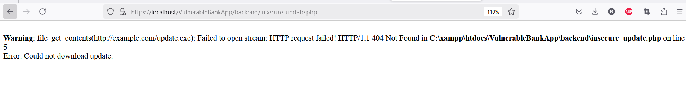

- Steps of Malicious Request / Attack and Impact
Step 1: Exploiting Unverified Software Updates
Malicious Request:
- The application automatically fetches and installs updates from an external URL without verifying the update's integrity (e.g., via a cryptographic signature).
- An attacker intercepts the request, replacing the update file with a malicious version.
Impact:
- Malicious code execution, leading to data breaches, ransomware, or full system compromise.
Step 2: Supply Chain Attack via Compromised Dependencies
Malicious Request:
- The application installs a package from a public repository without verifying its authenticity.
- An attacker replaces a popular package with a malicious one (e.g., dependency confusion attack).
Impact:
- The attacker gains control over the application, stealing sensitive data or executing arbitrary commands.
Step 3: CI/CD Pipeline Compromise
Malicious Request:
- A developer’s compromised credentials allow an attacker to push unauthorized code to the production branch.
- The CI/CD system automatically deploys the code without review.
Impact:
- Backdoors, malware, or unauthorized modifications are deployed into production, affecting all users.
Step 4: Insecure Deserialization Attack
Malicious Request:
- The system receives serialized data from a user without integrity checks.
- The attacker crafts a serialized payload that executes arbitrary code upon deserialization.
Impact:
- Remote Code Execution (RCE), privilege escalation, and system takeover.
- Code Before and After Fixes
Vulnerable Code (Before Fix)
Insecure_update.php
// Insecure software update: No validation, no authentication, no integrity check
$url = "http://example.com/update.exe"; // Uses HTTP (not HTTPS)
$file_data = file_get_contents($url); // No verification of source authenticity
if ($file_data === false) {
die("Error: Could not download update.");
}
file_put_contents("update.exe", $file_data); // Stores the unverified file
exec("update.exe"); // Directly executes an untrusted file

insecure_deserialization.php
// Insecure Deserialization - Accepts user input and unserializes it without validation
if ($_SERVER['REQUEST_METHOD'] === 'POST') {
$data = $_POST['payload']; // Attacker-controlled input
$object = unserialize($data); // Unsecure: Can execute arbitrary code
echo "Object unserialized successfully!";
} else {
echo "Send a POST request with serialized data.";
}

Secure Code (After Fix)
Secure_update.php
// Secure software update: Uses HTTPS, verifies integrity, prevents unauthorized execution
$url = "https://trustedsource.com/update.exe"; // Ensure HTTPS is used
$expected_hash = "your_expected_sha256_hash_here"; // Replace with the actual hash
// Download the update securely
$file_data = file_get_contents($url);
if ($file_data === false) {
die("Error: Could not download update.");
}
// Save the file
$file_path = "update.exe";
file_put_contents($file_path, $file_data);
// Verify file integrity using SHA-256 hash
$downloaded_hash = hash_file("sha256", $file_path);
if ($downloaded_hash !== $expected_hash) {
unlink($file_path); // Delete the corrupted file
die("Error: Integrity check failed. Update file is not trusted.");
}
echo "Update downloaded and verified successfully. Manual execution required.";
// DO NOT automatically execute the update
// Instead, require an admin to manually inspect and run the update
secure_deserialization.php
// Secure Deserialization: Prevents arbitrary code execution
if ($_SERVER['REQUEST_METHOD'] === 'POST') {
$data = $_POST['payload']; // User input
// Use JSON instead of PHP serialization to prevent object injection
$decoded_data = json_decode($data, true);
if (json_last_error() !== JSON_ERROR_NONE) {
die("Error: Invalid data format.");
}
echo "Data received and safely processed!";
} else {
echo "Send a POST request with JSON data.";
}
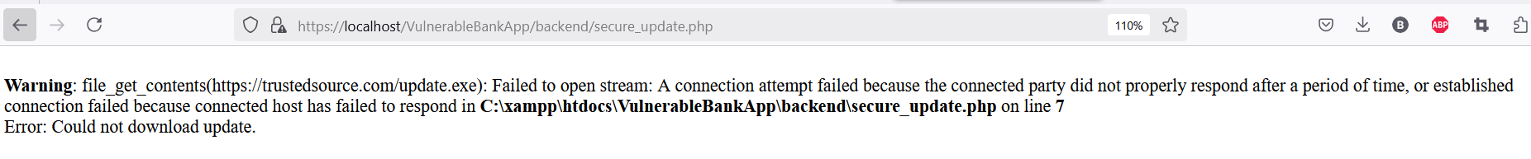
- Description of Fixes
Fix 1: Secure Software Updates
- Implemented cryptographic signature verification for updates before execution.
- Enforced HTTPS for all update requests.
Fix 2: Secure Dependency Management
- Used checksum validation to verify the integrity of third-party packages.
- Downloaded dependencies only from trusted sources.
Fix 3: Securing the CI/CD Pipeline
- Enforced signed commits and required multi-factor authentication for repository access.
- Implemented automated security checks in the pipeline (e.g., dependency scanning, static analysis).
Fix 4: Secure Data Serialization
- Replaced unserialize() with json_decode() to prevent remote code execution.
- Implemented digital signatures for verifying serialized data integrity.

- OWASP Vulnerability Category & Name
- Category: A09:2021 – Security Logging and Monitoring Failures
- Vulnerability Name: Lack of Proper Logging and Monitoring Mechanisms
- Description
Security Logging and Monitoring Failures occur when applications do not properly log security-related events, making it difficult to detect and respond to malicious activities. The absence of adequate logging can allow attackers to perform unauthorized actions, such as brute-force attacks, privilege escalations, or account takeovers, without being noticed.
Common issues include:
- No logs for unauthorized access attempts.
- No logs for failed login attempts.
- No logs for failed SQL queries.
- Exposing sensitive error messages to users instead of logging them securely.
3.Image of Beginning Request
(Screenshot of login attempts, lockouts and complaint submission without logging in the database)
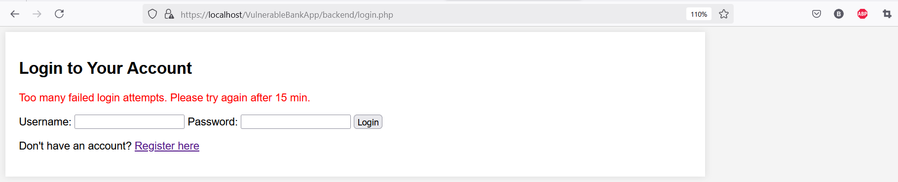
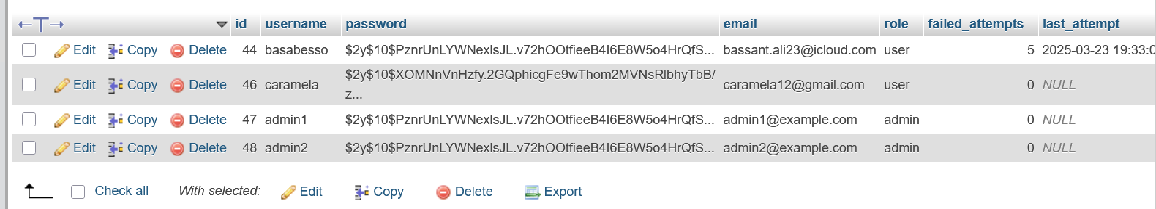

4.Steps of Malicious Request / Attack and Impact
Step 1: Brute Force Attack Without Detection
Malicious Request:
- The attacker automates login attempts using different username-password combinations.
- The application does not log failed login attempts, making it impossible to detect repeated unauthorized access attempts.
Impact:
- Unauthorized account access if a weak password is guessed.
- No alerts or monitoring make it easier for attackers to continue their attack unnoticed.
- Increased risk of account takeovers and data breaches.
Step 2: SQL Injection Attack Without Logging
Malicious Request:
- The attacker injects malicious SQL queries (e.g., admin' OR '1'='1) into login or search fields.
- The application does not log failed queries or suspicious database interactions.
Impact:
- The attacker retrieves or modifies sensitive data without detection.
- Database integrity is compromised, and unauthorized data exposure occurs.
- Lack of logging prevents forensic investigation after an attack.
Step 3: Privilege Escalation Without Auditing
Malicious Request:
- The attacker exploits missing access control checks to gain unauthorized privileges.
- No logs capture changes in user roles, privilege escalations, or admin actions.
Impact:
- The attacker gains higher-level access (e.g., admin privileges) and can make unauthorized changes.
- Without logs, it is impossible to track who made changes or detect unauthorized modifications.
- Compliance violations if sensitive data access is not monitored.
Step 4: No Alert for Multiple Failed Login Attempts
Malicious Request:
- The attacker attempts multiple incorrect logins to discover valid credentials.
- The application does not trigger alerts or lockouts after repeated failed login attempts.
Impact:
- The attacker can use credential stuffing to gain access to user accounts.
- No detection or alerts allow the attacker to continue attacking without restrictions.
- Increased risk of mass account compromise.
Step 5: Sensitive Errors Exposed Instead of Logged
Malicious Request:
- The attacker manipulates requests to trigger system errors (e.g., submitting invalid data).
- Instead of logging errors securely, the application displays them to the user, revealing sensitive system details.
Impact:
- The attacker learns about database structures, API endpoints, or server configurations.
- Exposed error messages make it easier to craft further attacks.
- Lack of internal logging prevents security teams from identifying and mitigating the issue.
5. Code Before and After Fixes
Vulnerable Code (Before Fix)
Admin_dashboard.php
// No logging for unauthorized access attempts
if (!isset($_SESSION['user_id']) || $_SESSION['role'] !== 'admin') {
die("Unauthorized access! Admins only. <a href='login.php'>Login</a>");
}

// No logging for SQL failures
if (!$result) {
// Fix: Security Misconfiguration: Exposing detailed SQL error messages
echo "Error fetching user data. Please try again later.";
}
Complaints.php
// No logging for unauthorized access attempts
if (!isset($_SESSION['user_id']) || $_SESSION['role'] !== 'user') {
die("Unauthorized access! Only users can upload complaints. <a href='login.php'>Login</a>");
}

// No logging for file upload errors
if (!isset($file) || $file['error'] !== UPLOAD_ERR_OK) {
$message = "Error uploading file.";
} else

// No error handling for database query
$stmt = $conn->prepare("INSERT INTO complaints (user_id, file_path, date) VALUES (?, ?, NOW())");
$stmt->bind_param("is", $user_id, $file_path);
if ($stmt->execute()) {
$message = "Complaint uploaded successfully!";
} else {
$message = "Database error: Could not save complaint."; // No logging for DB failures
}
Login.php
// No logging for account lockout

if ($user['failed_attempts'] >= $max_attempts && (time() - strtotime($user['last_attempt'])) < $lockout_time) {
$error = "Too many failed login attempts. Please try again after 15 min.";
}

// No logging for successful logins
// No logging for admin access

// No logging for failed login attempts
if (isset($user['failed_attempts'])) {
$update_stmt = $conn->prepare("UPDATE users SET failed_attempts = failed_attempts + 1, last_attempt = NOW() WHERE id = ?");
$update_stmt->bind_param("i", $user['id']);
$update_stmt->execute();
}
Logs.php
// No logging for unauthorized access attempts
if (!isset($_SESSION['user_id']) || $_SESSION['role'] !== 'admin') {
die("Unauthorized access! <a href='login.php'>Login</a>");
}

// No logging when an admin accesses the logs
// There's no record of when an admin successfully views logs.
// No logging if a database error occurs
if (!$logs) {
// Fix: Do not expose SQL error details to the user
echo "An error occurred while fetching logs. Please try again later.";
}
Register.php
if ($sql->execute()) {
$message = "Registration successful! <a href='login.php'>Login</a>";
} else {
// Fix: Generic error message to prevent information disclosure
// Issue: No logging for failed attempts
$message = "Registration failed. Please try again later.";
}
statement.php
// No logging of unauthorized access attempts
if (!isset($_SESSION['user_id'])) {
die("Unauthorized access! <a href='login.php'>Login</a>");
}

// No logging of invalid or hijacked sessions
$checkUser = $conn->prepare("SELECT id FROM users WHERE id = ?");
$checkUser->bind_param("i", $user_id);
$checkUser->execute();
$result = $checkUser->get_result();
if ($result->num_rows === 0) {
die("Unauthorized access! User does not exist.");
}
Transfer.php
if ($from_account_result->num_rows == 0) {
// No log for unauthorized attempt
$message = "Error: You are not authorized to transfer from this account.";
} else
if ($to_account_result->num_rows == 0) {
// No log for transfer to invalid account
$message = "Error: To account does not exist.";
} else

if ($from_account_data['balance'] < $amount) {
// No log for failed transactions
throw new Exception("Error: Insufficient balance in the from account.");
}

$conn->commit();
$message = "Transfer successful!";
} catch (Exception $e) {
// Fix: Rollback if any query fails to prevent partial money transfer
$conn->rollback();
// Error messages are shown to users instead of logging securely
$message = $e->getMessage();
}

if (!$accounts) {
// No logging of database errors
die("Error retrieving account information. Please try again later.");
}
user_dashboard.php
// VULNERABILITY: No logging of errors
die("An error occurred. Please try again later."); // Show generic error message

secure code (fixed code)
login.php
// Centralized Security Logging Function
function logSecurityEvent($conn, $event, $user_id = NULL) {
$stmt = $conn->prepare("INSERT INTO security_logs (user_id, event, ip_address, user_agent, timestamp)
VALUES (?, ?, ?, ?, NOW())");
if ($stmt) {
$ip_address = getClientIP(); // Get the client IP address
$user_agent = $_SERVER['HTTP_USER_AGENT'] ?? 'UNKNOWN'; // Get the user agent
$stmt->bind_param("isss", $user_id, $event, $ip_address, $user_agent);
$stmt->execute();
$stmt->close();
} else {
error_log("SECURITY LOG FAILURE: Failed to log event - " . $event . " for User ID: " . ($user_id ?? "unknown"));
}
}
// Function to get client IP
function getClientIP() {
if (!empty($_SERVER['HTTP_CLIENT_IP'])) {
return $_SERVER['HTTP_CLIENT_IP'];
} elseif (!empty($_SERVER['HTTP_X_FORWARDED_FOR'])) {
return $_SERVER['HTTP_X_FORWARDED_FOR'];
} else {
return $_SERVER['REMOTE_ADDR'];
}
}

if ($user['failed_attempts'] >= $max_attempts && (time() - strtotime($user['last_attempt'])) < $lockout_time) {
logSecurityEvent($conn, $user['id'], "Account Locked - Too many failed login attempts");
$error = "Too many failed login attempts. Please try again after 15 min.";
}

// Log failed login attempt
logSecurityEvent($conn, $user['id'], "Failed Login - Incorrect password");
$error = "Invalid username or password!";

// Log failed login attempt for unknown username
logSecurityEvent($conn, NULL, "Failed Login - Unknown username: $username");
$error = "Invalid username or password!";
}

// Log database connection errors
if ($conn->connect_error) {
error_log("Database connection error: " . $conn->connect_error, 0);
}
Admin_dashboard.php
/ Centralized Security Logging Function
function logSecurityEvent($conn, $event, $user_id = NULL) {
$stmt = $conn->prepare("INSERT INTO security_logs (user_id, event, ip_address, user_agent, timestamp) VALUES (?, ?, ?, ?, NOW())");
if ($stmt) {
$ip_address = getClientIP(); // Get the client IP address
$user_agent = $_SERVER['HTTP_USER_AGENT'] ?? 'UNKNOWN'; // Get the user agent
$stmt->bind_param("isss", $user_id, $event, $ip_address, $user_agent);
$stmt->execute();
$stmt->close();
} else {
error_log("SECURITY LOG FAILURE: Failed to log event - " . $event . " for User ID: " . ($user_id ?? "unknown"));
}
}
// Function to get client IP
function getClientIP() {
if (!empty($_SERVER['HTTP_CLIENT_IP'])) {
return $_SERVER['HTTP_CLIENT_IP'];
} elseif (!empty($_SERVER['HTTP_X_FORWARDED_FOR'])) {
return $_SERVER['HTTP_X_FORWARDED_FOR'];
} else {
return $_SERVER['REMOTE_ADDR'];
}
}

// Secure Role-Based Access Control (RBAC) with logging
if (!isset($_SESSION['user_id']) || $_SESSION['role'] !== 'admin') {
logSecurityEvent($conn, "Unauthorized access attempt - User not an admin");
die("Unauthorized access! Admins only. <a href='login.php'>Login</a>");
}

if (!$result) {
// Log SQL failure to database for security auditing
logSecurityEvent($conn, "Database query failure: Failed to fetch user data");
// Log to system error logs for debugging (web server logs or PHP error log)
error_log("Database query failed for user ID: $user_id");
// Show a generic message to the user (Avoid exposing errors)
echo "Error fetching user data. Please try again later.";
}

// Log access to the user dashboard
logSecurityEvent($conn, "Accessed admin dashboard", $user_id);
complaints.php
/ Centralized Security Logging Function
function logSecurityEvent($conn, $event, $user_id = NULL) {
$stmt = $conn->prepare("INSERT INTO security_logs (user_id, event, ip_address, user_agent, timestamp) VALUES (?, ?, ?, ?, NOW())");
if ($stmt) {
$ip_address = getClientIP(); // Get the client IP address
$user_agent = $_SERVER['HTTP_USER_AGENT'] ?? 'UNKNOWN'; // Get the user agent
$stmt->bind_param("isss", $user_id, $event, $ip_address, $user_agent);
$stmt->execute();
$stmt->close();
} else {
error_log("SECURITY LOG FAILURE: Failed to log event - " . $event . " for User ID: " . ($user_id ?? "unknown"));
}
}
// Function to get client IP
function getClientIP() {
if (!empty($_SERVER['HTTP_CLIENT_IP'])) {
return $_SERVER['HTTP_CLIENT_IP'];
} elseif (!empty($_SERVER['HTTP_X_FORWARDED_FOR'])) {
return $_SERVER['HTTP_X_FORWARDED_FOR'];
} else {
return $_SERVER['REMOTE_ADDR'];
}
}

if (!isset($_SESSION['user_id']) || $_SESSION['role'] !== 'user') {
logSecurityEvent($conn, "Unauthorized access attempt - User ID: " . ($_SESSION['user_id'] ?? "unknown") . " tried to upload complaints without permission.", $_SESSION['user_id'] ?? NULL);
die("Unauthorized access! Only users can upload complaints. <a href='login.php'>Login</a>");
}

// Log file upload attempts with specific errors
if (!isset($file) || $file['error'] !== UPLOAD_ERR_OK) {
logSecurityEvent($conn, "File upload error - User ID: $user_id, Error Code: " . $file['error'], $user_id);
$message = "Error uploading file.";
} else

$allowed_types = ['image/jpeg', 'image/png', 'application/pdf'];
if (!in_array($file['type'], $allowed_types)) {
logSecurityEvent($conn, "Invalid file type upload attempt - User ID: $user_id, File Type: " . $file['type'], $user_id);
$message = "Invalid file type. Only JPG, PNG, and PDF files are allowed.";
} else

if ($stmt->execute()) {
logSecurityEvent($conn, "Complaint uploaded successfully - User ID: $user_id, File: $safe_file_name", $user_id);
$message = "Complaint uploaded successfully!";
} else {
logSecurityEvent($conn, "Database error: Failed to save complaint - User ID: $user_id, Error: " . $stmt->error, $user_id);
error_log("Database error: Could not save complaint for user ID: $user_id. Error: " . $stmt->error);
$message = "Database error: Could not save complaint.";
}
$stmt->close();
} else {
logSecurityEvent($conn, "File move error - User ID: $user_id, File: $safe_file_name", $user_id);
$message = "Error moving uploaded file.";
}
messages.php
// Centralized Security Logging Function
function logSecurityEvent($conn, $event, $user_id = NULL) {
$stmt = $conn->prepare("INSERT INTO security_logs (user_id, event, ip_address, user_agent, timestamp) VALUES (?, ?, ?, ?, NOW())");
if ($stmt) {
$ip_address = getClientIP(); // Get the client IP address
$user_agent = $_SERVER['HTTP_USER_AGENT'] ?? 'UNKNOWN'; // Get the user agent
$stmt->bind_param("isss", $user_id, $event, $ip_address, $user_agent);
$stmt->execute();
$stmt->close();
} else {
error_log("SECURITY LOG FAILURE: Failed to log event - " . $event . " for User ID: " . ($user_id ?? "unknown"));
}
}
// Function to get client IP
function getClientIP() {
if (!empty($_SERVER['HTTP_CLIENT_IP'])) {
return $_SERVER['HTTP_CLIENT_IP'];
} elseif (!empty($_SERVER['HTTP_X_FORWARDED_FOR'])) {
return $_SERVER['HTTP_X_FORWARDED_FOR'];
} else {
return $_SERVER['REMOTE_ADDR'];
}
}

// Role-Based Access Control (RBAC)
if (!isset($_SESSION['user_id']) || $_SESSION['role'] !== 'user') {
logSecurityEvent($conn, "Unauthorized access attempt - User ID: " . ($_SESSION['user_id'] ?? "unknown") . " tried to send a message without permission.", $_SESSION['user_id'] ?? NULL);
die("Unauthorized access! Only users can send messages. <a href='login.php'>Login</a>");
}

$stmt = $conn->prepare("SELECT id FROM users WHERE id = ?");
if (!$stmt) {
error_log("SQL Error select users: " . $conn->error);
die("Prepare failed: " . $conn->error);
}

if ($result->num_rows === 0) {
logSecurityEvent($conn, "Unauthorized access - User ID does not exist", $user_id);
die("Unauthorized access! User does not exist.");
}
$stmt->close();
// Enforce message length limit
if (strlen($user_message) > 500) {
logSecurityEvent($conn, "Message rejected - Too long", $user_id);
die("Message is too long. Maximum 500 characters allowed.");
}
// Implement rate limiting to prevent spam
$stmt = $conn->prepare("SELECT sent_at FROM messages WHERE user_id = ? ORDER BY sent_at DESC LIMIT 1");
if (!$stmt) {
error_log("SQL Error select messages : " . $conn->error);
die("Prepare failed: " . $conn->error);
}

$last_time = strtotime($row['sent_at']);
if (time() - $last_time < 10) { // Enforce 10-second delay between messages
logSecurityEvent($conn, "Rate limit exceeded - User ID: $user_id", $user_id);
die("Please wait before sending another message.");
}

// Use prepared statements for inserting messages
$stmt = $conn->prepare("INSERT INTO messages (user_id, message, sent_at) VALUES (?, ?, NOW())");
if (!$stmt) {
error_log("SQL Error insert messages : " . $conn->error);
die("An error occurred. Please try again.");
}
$stmt->bind_param("is", $user_id, $user_message);
$stmt->execute();
$stmt->close();
// Log the action using prepared statements
$stmt = $conn->prepare("INSERT INTO logs (user_id, action, timestamp) VALUES (?, ?, NOW())");
if (!$stmt) {
error_log("SQL Error insert logs: " . $conn->error);
die("An error occurred. Please try again.");
}
$log_action = "Sent a message";
$stmt->bind_param("is", $user_id, $log_action);
$stmt->execute();
$stmt->close();
$message = "Message sent successfully!";
}
Read_Messages.php
// Centralized Security Logging Function
function logSecurityEvent($conn, $event, $user_id = NULL) {
$stmt = $conn->prepare("INSERT INTO security_logs (user_id, event, ip_address, user_agent, timestamp)
VALUES (?, ?, ?, ?, NOW())");
if ($stmt) {
$ip_address = $_SERVER['REMOTE_ADDR'] ?? 'UNKNOWN';
$user_agent = $_SERVER['HTTP_USER_AGENT'] ?? 'UNKNOWN';
$stmt->bind_param("isss", $user_id, $event, $ip_address, $user_agent);
$stmt->execute();
$stmt->close();
} else {
error_log("SECURITY LOG FAILURE: Failed to log event - " . $event . " for User ID: " . ($user_id ?? "unknown"));
}
}
// Function to get client IP
function getClientIP() {
if (!empty($_SERVER['HTTP_CLIENT_IP'])) {
return $_SERVER['HTTP_CLIENT_IP'];
} elseif (!empty($_SERVER['HTTP_X_FORWARDED_FOR'])) {
return $_SERVER['HTTP_X_FORWARDED_FOR'];
} else {
return $_SERVER['REMOTE_ADDR'];
}
}
$ip_address = getClientIP();
$user_agent = $_SERVER['HTTP_USER_AGENT'] ?? 'Unknown';
// Improved Security Logging for Unauthorized Access
if (!isset($_SESSION['user_id']) || $_SESSION['role'] !== 'admin') {
logSecurityEvent($conn, "Unauthorized access attempt", $_SESSION['user_id'] ?? NULL);
die("Unauthorized access! <a href='login.php'>Login</a>");
}

if ($result->num_rows === 0) {
logSecurityEvent($conn, "Stale session detected - User ID does not exist", $_SESSION['user_id']);
die("Unauthorized access! User does not exist.");
}

// Logging Admin Message Retrieval
logSecurityEvent($conn, "Admin viewed messages", $_SESSION['user_id']);
Resgister.php
// Centralized Security Logging Function
function logSecurityEvent($conn, $event, $username = NULL, $email = NULL) {
$stmt = $conn->prepare("INSERT INTO security_logs (event, username, email, ip_address, user_agent, timestamp)
VALUES (?, ?, ?, ?, ?, NOW())");
if ($stmt) {
$ip_address = $_SERVER['REMOTE_ADDR'] ?? 'UNKNOWN';
$user_agent = $_SERVER['HTTP_USER_AGENT'] ?? 'UNKNOWN';
$stmt->bind_param("sssss", $event, $username, $email, $ip_address, $user_agent);
$stmt->execute();
$stmt->close();
} else {
error_log("SECURITY LOG FAILURE: Failed to log event - " . $event . " for User: " . ($username ?? "unknown"));
}
}
// Function to get client IP
function getClientIP() {
if (!empty($_SERVER['HTTP_CLIENT_IP'])) {
return $_SERVER['HTTP_CLIENT_IP'];
} elseif (!empty($_SERVER['HTTP_X_FORWARDED_FOR'])) {
return $_SERVER['HTTP_X_FORWARDED_FOR'];
} else {
return $_SERVER['REMOTE_ADDR'];
}
}

if (!$email) {
logSecurityEvent($conn, "Invalid email format attempt", $username, $_POST['email']);
die("Invalid email format!");
}

if ($result->num_rows > 0) {
logSecurityEvent($conn, "Duplicate email registration attempt", $username, $email);
die("Email already in use!");
}

if ($sql->execute()) {
logSecurityEvent($conn, "Successful registration", $username, $email);
$message = "Registration successful! <a href='login.php'>Login</a>";
} else {
// Fix: Generic error message to prevent information disclosure
// Fix: Log failed registration attempts
logSecurityEvent($conn, "Failed registration attempt", $username, $email);
$message = "Registration failed. Please try again later.";
}
statements.php
// Centralized Security Logging Function
function logSecurityEvent($conn, $event, $user_id = NULL) {
$stmt = $conn->prepare("INSERT INTO security_logs (user_id, event, ip_address, user_agent, timestamp)
VALUES (?, ?, ?, ?, NOW())");
if ($stmt) {
$ip_address = getClientIP(); // Get the client IP address
$user_agent = $_SERVER['HTTP_USER_AGENT'] ?? 'UNKNOWN'; // Get the user agent
$stmt->bind_param("isss", $user_id, $event, $ip_address, $user_agent);
$stmt->execute();
$stmt->close();
} else {
error_log("SECURITY LOG FAILURE: Failed to log event - " . $event . " for User ID: " . ($user_id ?? "unknown"));
}
}
// Function to get client IP
function getClientIP() {
if (!empty($_SERVER['HTTP_CLIENT_IP'])) {
return $_SERVER['HTTP_CLIENT_IP'];
} elseif (!empty($_SERVER['HTTP_X_FORWARDED_FOR'])) {
return $_SERVER['HTTP_X_FORWARDED_FOR'];
} else {
return $_SERVER['REMOTE_ADDR'];
}
}
if (!isset($_SESSION['user_id'])) {
logSecurityEvent($conn, "Unauthorized access attempt - No session", NULL);
die("Unauthorized access! <a href='login.php'>Login</a>");
}

if ($result->num_rows === 0) {
logSecurityEvent($conn, "Unauthorized access attempt - User does not exist", $user_id);
die("Unauthorized access! User does not exist.");
}

// Log the successful retrieval of transactions
logSecurityEvent($conn, "Successful view statements", $user_id);
Transfer.php
// Centralized Security Logging Function
function logSecurityEvent($conn, $event, $user_id = NULL) {
$stmt = $conn->prepare("INSERT INTO security_logs (user_id, event, ip_address, user_agent, timestamp)
VALUES (?, ?, ?, ?, NOW())");
if ($stmt) {
$ip_address = getClientIP(); // Get the client IP address
$user_agent = $_SERVER['HTTP_USER_AGENT'] ?? 'UNKNOWN'; // Get the user agent
$stmt->bind_param("isss", $user_id, $event, $ip_address, $user_agent);
$stmt->execute();
$stmt->close();
} else {
error_log("SECURITY LOG FAILURE: Failed to log event - " . $event . " for User ID: " . ($user_id ?? "unknown"));
}
}
// Function to get client IP
function getClientIP() {
if (!empty($_SERVER['HTTP_CLIENT_IP'])) {
return $_SERVER['HTTP_CLIENT_IP'];
} elseif (!empty($_SERVER['HTTP_X_FORWARDED_FOR'])) {
return $_SERVER['HTTP_X_FORWARDED_FOR'];
} else {
return $_SERVER['REMOTE_ADDR'];
}
}

if ($from_account === $to_account) {
logSecurityEvent($conn, "Attempted transfer from and to the same account: $from_account", $user_id);
$message = "Error: You cannot transfer to the same account.";
} else

if ($from_account_result->num_rows == 0) {
// Log unauthorized access attempt
logSecurityEvent($conn, "Unauthorized transfer attempt from account: $from_account", $user_id);
$message = "Error: You are not authorized to transfer from this account.";
} else

if ($to_account_result->num_rows == 0) {
// Log invalid transfer to non-existent account
logSecurityEvent($conn, "Transfer attempt to invalid account: $to_account", $user_id);
$message = "Error: To account does not exist.";
} else

if ($from_account_data['balance'] < $amount) {
// Log failed transaction due to insufficient balance
logSecurityEvent($conn, "Failed transaction due to insufficient balance in account: $from_account", $user_id);
throw new Exception("Error: Insufficient balance in the from account.");
}

$conn->commit();
$message = "Transfer successful!";
// Log successful transaction
logSecurityEvent($conn, "Successful transfer of $amount from $from_account to $to_account", $user_id);
} catch (Exception $e) {
// Fix: Rollback if any query fails to prevent partial money transfer
$conn->rollback();
// Log the error
logSecurityEvent($conn, "Transaction failed: " . $e->getMessage(), $user_id);
$message = $e->getMessage();
}

// Fix: Hide internal database error details
if (!$accounts) {
// Log database error
logSecurityEvent($conn, "Database error while fetching accounts", $user_id);
die("Error retrieving account information. Please try again later.");
}

User_dashboard.php
// Centralized Security Logging Function
function logSecurityEvent($conn, $event, $user_id = NULL) {
$stmt = $conn->prepare("INSERT INTO security_logs (user_id, event, ip_address, user_agent, timestamp)
VALUES (?, ?, ?, ?, NOW())");
if ($stmt) {
$ip_address = getClientIP(); // Get the client IP address
$user_agent = $_SERVER['HTTP_USER_AGENT'] ?? 'UNKNOWN'; // Get the user agent
$stmt->bind_param("isss", $user_id, $event, $ip_address, $user_agent);
$stmt->execute();
$stmt->close();
} else {
error_log("SECURITY LOG FAILURE: Failed to log event - " . $event . " for User ID: " . ($user_id ?? "unknown"));
}
}
// Function to get client IP
function getClientIP() {
if (!empty($_SERVER['HTTP_CLIENT_IP'])) {
return $_SERVER['HTTP_CLIENT_IP'];
} elseif (!empty($_SERVER['HTTP_X_FORWARDED_FOR'])) {
return $_SERVER['HTTP_X_FORWARDED_FOR'];
} else {
return $_SERVER['REMOTE_ADDR'];
}
}
// Implement Role-Based Access Control (RBAC) to restrict access
if (!isset($_SESSION['user_id']) || $_SESSION['role'] !== 'user') {
// Log unauthorized access attempt
logSecurityEvent($conn, "Unauthorized access attempt", $_SESSION['user_id'] ?? null);
die("Unauthorized access! <a href='login.php'>Login</a>");
}

if (!$result) {
// FIX: Hide detailed database errors from users
logSecurityEvent($conn, "Unauthorized attempt to access user data (User ID: $user_id)", $user_id);
die("An error occurred. Please try again later."); // Show generic error message
}
$user = $result->fetch_assoc();
// Log access to the user dashboard
logSecurityEvent($conn, "Accessed user dashboard", $user_id);

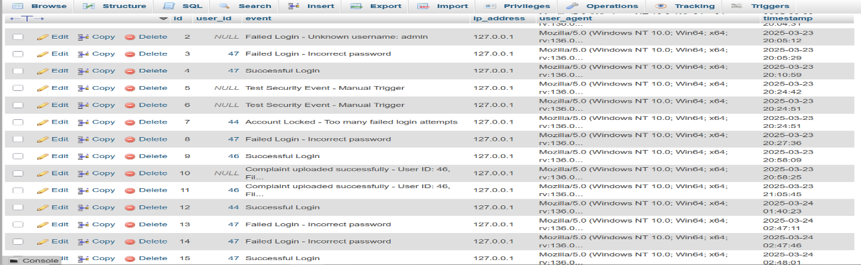
6.Description of fixes
Fix 1: Implemented Centralized Security Logging
- Introduced a logSecurityEvent function to log security events such as unauthorized access, failed logins, and database query failures.
- Ensured logs are securely stored and only accessible to authorized users.
Fix 2: Enhanced Unauthorized Access Handling
- Added logging for unauthorized access attempts across multiple files (Admin_dashboard.php, Complaints.php, Logs.php).
- Ensured security logs capture user details, timestamps, and attempted actions.
Fix 3: Logged Admin Access to Security Logs
- Implemented logging whenever an admin accesses security logs.
- Ensured accountability by tracking admin activities and preventing unauthorized modifications to logs.
Fix 4: Implemented Account Lockout Logging
- Logged failed login attempts and account lockouts to detect brute-force attacks.
- Enabled alerts for repeated login failures to notify administrators of potential threats.
Fix 5: Secure File Upload Logging
- Logged all file upload attempts, including failures, to detect malicious file uploads.
- Ensured detailed records of user activity related to file handling.
Fix 6: Secure Financial Transaction Logging
- Logged all financial transactions, including unauthorized transfer attempts.
- Implemented alerts for unusual or high-value transactions to detect fraudulent activities.

- OWASP Vulnerability Category & Name
- Category: A10:2021 – Server-Side Request Forgery (SSRF)
- Vulnerability Name: Unauthorized internal resource access via manipulated requests
- Description
The application is vulnerable to Server-Side Request Forgery (SSRF), which allows attackers to manipulate server requests to access unauthorized internal resources. This vulnerability was found in the functionality where users are allowed to provide URLs for fetching files. The lack of proper input validation in this feature allows an attacker to submit URLs targeting internal network resources like localhost, 127.0.0.1, or cloud metadata services, potentially exposing sensitive internal data or services.
Issues Identified:
- Access to Internal Resources: Attackers can submit URLs pointing to internal resources, such as local network services (e.g., localhost, 127.0.0.1), allowing unauthorized access to sensitive internal systems.
- Sensitive Data Exposure: SSRF attacks can expose internal metadata, such as credentials stored in cloud environments (e.g., AWS EC2 metadata).
- Bypassing Firewalls: SSRF can bypass firewalls by targeting internal services that are protected from external access.
- Image of Beginning Request
(Screenshot showing an attacker providing an internal URL in a request field to access a restricted resource, such as an admin panel or internal API.)
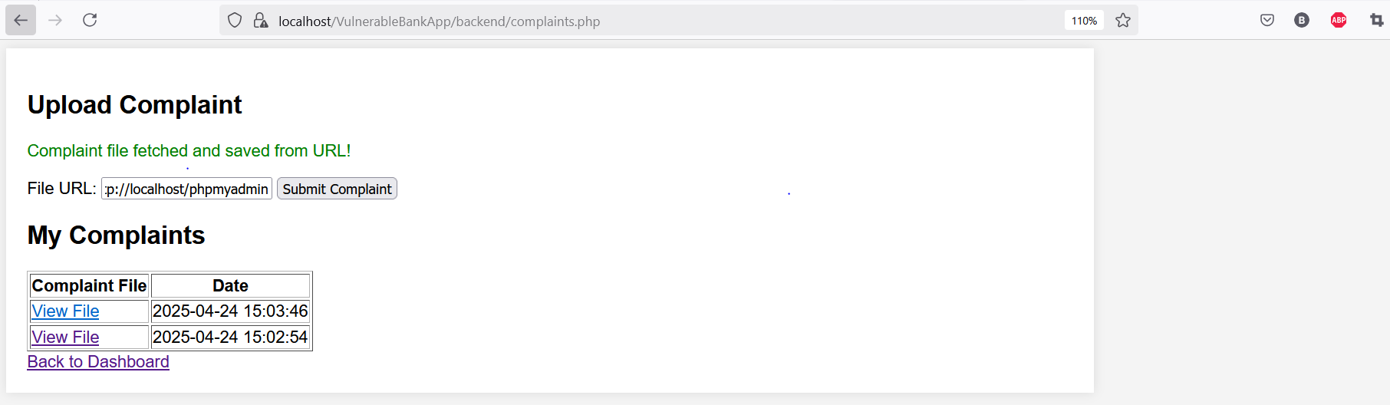
- Steps of Malicious Request / Attack and Impact
Step 1: Exploiting Open URL Fetching
Malicious Request:
The attacker submits a request to fetch a file from an external URL but manipulates it to target internal resources like:
http://localhost:8080/internal-api
Impact:
- The attacker can access internal web applications, APIs, or services that should not be accessible to external users. Sensitive data may be leaked as a result.

Step 2: Accessing Internal Metadata Services
Malicious Request:
The attacker submits a URL pointing to an internal cloud metadata service:
Impact:
- The attacker gains access to sensitive metadata, such as AWS EC2 instance credentials, which can be used to escalate privileges or take control of cloud instances.
Step 3: Scanning and Attacking Internal Network Services
Malicious Request:
The attacker attempts to scan and exploit internal services by submitting URLs targeting internal endpoints:
http://localhost:3000/admin
Impact:
- The attacker discovers internal services and vulnerabilities, potentially leading to unauthorized internal network attacks.
- Code Before and After Fixes
Vulnerable Code (Before Fix)
if ($_SERVER["REQUEST_METHOD"] == "POST") {
$user_id = $_SESSION['user_id'];
$file_url_mode = isset($_POST['file_url']) && filter_var($_POST['file_url'], FILTER_VALIDATE_URL);
$file = $file_url_mode ? null : ($_FILES['complaint_file'] ?? null);
if ($file_url_mode) {
$url = $_POST['file_url'];
$file_contents = @file_get_contents($url); // SSRF vulnerability: Allows internal resources to be accessed
if ($file_contents !== false) {
$upload_dir = "uploads/";
$safe_file_name = time() . "_remote_file";
$file_path = $upload_dir . $safe_file_name;
file_put_contents($file_path, $file_contents);
$stmt = $conn->prepare("INSERT INTO complaints (user_id, file_path, date) VALUES (?, ?, NOW())");
$stmt->bind_param("is", $user_id, $file_path);
if ($stmt->execute()) {
logSecurityEvent($conn, "Complaint file fetched from URL: $url", $user_id);
$message = "Complaint file fetched and saved from URL!";
} else {
$message = "Database error.";
}
$stmt->close();
} else {
$message = "Failed to fetch file from URL.";
}
}
}

secure code (fixed code)
if ($_SERVER["REQUEST_METHOD"] == "POST") {
$user_id = $_SESSION['user_id'];
$file_url_mode = isset($_POST['file_url']) && filter_var($_POST['file_url'], FILTER_VALIDATE_URL);
$file = $file_url_mode ? null : ($_FILES['complaint_file'] ?? null);
if ($file_url_mode) {
$url = $_POST['file_url'];
// Validate and block internal cloud metadata services (e.g., AWS metadata URL)
$parsed_url = parse_url($url);
// Block access to internal resources (including AWS metadata service and localhost)
$blocked_hosts = ['localhost', '127.0.0.1', '169.254.169.254']; // List of blocked internal hosts (e.g., AWS metadata)
if (in_array($parsed_url['host'], $blocked_hosts)) {
logSecurityEvent($conn, "Blocked SSRF attempt - Access to internal resource: $url", $user_id);
die("Invalid URL. Access to internal resources is not allowed.");
}
// Attempt to fetch the file content
$file_contents = @file_get_contents($url);
if ($file_contents !== false) {
$upload_dir = "uploads/";
$safe_file_name = time() . "_remote_file";
$file_path = $upload_dir . $safe_file_name;
file_put_contents($file_path, $file_contents);
$stmt = $conn->prepare("INSERT INTO complaints (user_id, file_path, date) VALUES (?, ?, NOW())");
$stmt->bind_param("is", $user_id, $file_path);
if ($stmt->execute()) {
logSecurityEvent($conn, "Complaint file fetched from URL: $url", $user_id);
$message = "Complaint file fetched and saved from URL!";
} else {
$message = "Database error.";
}
$stmt->close();
} else {
$message = "Failed to fetch file from URL.";
}
}
}

The attacker submits the following URL in the form input for file fetching:
http://localhost:8080/internal-api
or
http://169.254.169.254/latest/meta-data/iam/security-credentials/
or
http://localhost:3000/admin
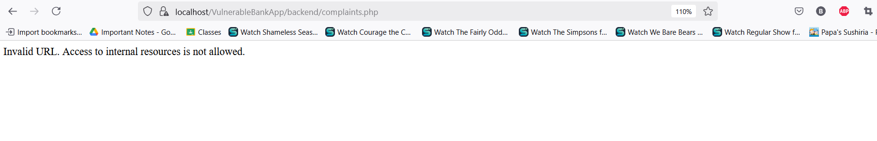

Description of Fixes:-
Fix 1: Block SSRF by Validating the URL
- Before: The application fetched files from URLs without checking whether the URLs pointed to internal resources.
- After: We added a validation step to block access to internal resources like localhost or 127.0.0.1. If such URLs are detected, the request is blocked, and an error message is shown.
Fix 2: Secure File Fetching
- Before: The application fetched files directly from user-provided URLs, which could lead to exposing internal services.
- After: The file fetching process now includes a check that ensures that only external URLs (not internal services) are fetched, preventing SSRF attacks.

